

# Collaborative Role of Nurses as Evaluated by Physicians, and Allied Health Partners: Input to the Formulation

**of a Role Enhancement Program**

A Thesis Proposal Presented to the Faculty of Concordia College Graduate School

In Partial Fulfillment of Requirement For the Degree of Masters of

Science in Nursing

**Mr. Bradley Goldie Loo, RN**



|  |  |  |
| --- | --- | --- |
|  | **TABLE OF CONTENTS** |  |
| **Preliminaries** |  | **Page** |
| Title Page |  | i |
| Table of Contents |  | ii |
| List of Figures |  | v |
| Abstract |  | vii |

**Chapter I:**

THE PROBLEM AND ITS SETTING 1

Introduction 1

Theoretical Framework 4

Conceptual Framework 6

Statement of the Problem 7

Hypotheses 8

Scope and Limitation 9

Significance of the Study 9

Definition of Terms 11

Chapter II:

REVIEW OF RELATED LITERATURE 13

Clinical Ladder in Nursing Practice 13

Nurses as Collaborators 18



Collaboration Defined 20

Concept of Interdisciplinary Collaboration and Teamwork 21

Spectrum of Collaboration 22

Role of Trust in Collaboration 23

Key Success and Pitfalls in Collaboration 24

Benefits of Collaboration 25

Model of Interdisciplinary Collaboration 27

Values and Norms of Collaboration Principles 29

Core Competencies for Practice Collaboration 30

Task of the Team 31

Elements of Effective Collaboration 32

Collaboration and Knowledge-Sharing 32

Basic Principles of Collaboration 34

Organizational Factors Affecting Collaboration 34

Management/ Strategies 35

Defining Team effectiveness 37

Moving Forward to Effective Collaboration 38

Variables in Collaboration 39

Synthesis 51



Chapter III:

RESEARCH METHODOLOGY 53

Research Design 53

Sampling Technique and Sample 54

Population Frame and Sample 55

Research instrumentation 55

Data Gathering Procedure 57

Statistical Treatment 57

Chapter IV:

PRESENTATION, INTERPRETATION AND ANALYSIS OF DATA 59

Chapter V:

SUMMARY, FINDINGS, CONCLUSIONS AND RECOMMENDATIONS 99

Summary 99

Findings 105

Conclusions 112

Recommendations 112

BIBLIOGRAPHY 114

**APPENDICES**



**LIST OF FIGURES**

Figure 1.1: Frequency and Percentage Distribution on Age of Nurses 59

Figure 1.2: Frequency and Percentage Distribution on Gender of Nurses 60

Figure 1.3: Frequency and Percentage Distribution on Position of Nurses 61

Figure 1.4: Frequency and Percentage Distribution on Highest Educational Attainment of Nurses 62

Figure 1.5: Frequency and Percentage Distribution on Length of Work

Experience of Nurses 63

Figure 1.1: Frequency and Percentage Distribution on Career Path of

Staff Nurses 65

Figure 2.1.A. Mean Scores on Specific Items on Flexibility and Interdependence

as Evaluated by Physicians 66

Figure 2.1.B. Mean Scores on Specific Items on Flexibility and Interdependence

as \Evaluated by Allied Health Partners 69

Figure 2.2.A. Mean Scores on Specific Items on Communication as

Evaluated by Physicians 71

Figure 2.2.B. Mean Scores on Specific Items on Communication as

Evaluated by Allied Health Partners 74



Figure 2.3.A. Mean Scores on Specific Items on Collective Ownership of Goals

as Evaluated by Physicians 76

Figure 2.3.B. Mean Scores on Specific Items on Collective Ownership of Goals

as Evaluated by Allied Health Partners 78

Figure 2.4.A. Mean Scores on Specific Items on Reflective Process as

Evaluated by Physicians 81

Figure 2.4.B. Mean Scores on Specific Items on Reflective Process as

Evaluated by Allied Health Partners 83

Figure 3: Difference on the Evaluation of Physicians and Allied Health

Partners on the Collaborative Role of Nurses 86

Figure 4.1: Mean Scores of Specific Items under Flexibility and Interdependence 88 Figure 4.2: Mean Scores of Specific Items Under Communication 90

Figure 4.3: Mean Scores of Specific Items Under Collective Ownership of Goals 92

Figure 2.4: Mean Scores of Specific Items Under Reflective Process 94

Figure 5.1: Mean Scores of Collaboration of Nurses According to

Career Pathway 96

Figure 5.2: Difference in the Performance of the Collaborative Roles of

Nurses Grouped According to Career Pathway 97



# ABSTRACT

**Title:** Collaborative Roles of Nurses as Evaluated by Physicians, and Allied Health Partners: Input to the Formulation of a Role Enhancement Program

**Researcher :** Mr. Bradley Goldie K. Loo, RN

**School** : Concordia College

**Degree** : Master of Science in Nursing: Major in Nursing Administration

**Adviser** : Dr. Rodolfo Borromeo, RN, MAN, EdD

**Date of Defense** : March 11, 2009

## *Summary of the Study*

This research was undertaken to determine the collaborative role of nurses as evaluated by physicians, and allied health partners. This study aimed to have a good view and impart an in- depth understanding on the essentiality of collaboration in the field of health care and how important is the role of nurses in binding the health care team.

This research study stapled its foundation on theories, which were deemed indispensable: Career Pathway by Buhat (1999) and Collaboration Theory by Bronstein (2003). Specifically, it sought to answer the following questions:

1.1 What is the profile of nurses in terms of:



* 1. age
  2. gender;
  3. position;
  4. highest educational attainment;
  5. length of experience; and
  6. career path?

1. To what extent do the physicians and allied health partners evaluated the collaborative role of nurses along the following aspects:
   1. flexibility and interdependence;
   2. communication;
   3. collective ownership of goals; and
   4. reflective process?
2. How do the evaluation of the physicians and allied health partners differ on the collaborative role of nurses?
3. What are the scores obtained by the nurses’ own rating on their collaborative roles to the physicians and allied health partners in terms of:
   1. flexibility and interdependence;
   2. communication;
   3. collective ownership of goals; and

4.5 reflective process?



1. How do nurses differ in the performance of their collaborative roles when grouped according to their career pathway?
   1. novice;
   2. advance beginner; and
   3. competent?
2. What role enhancement program can be suggested to improve the collaboration of the staff nurses to the physicians and allied health partners?

This research covered the nurses in one selected tertiary hospital, namely, The Philippine Heart Center. The nurses included the novice nurses, advance beginner nurses, and the competent nurses working in all the different areas of the said institution. The nursing director was not included in the study. Respondents of the study also included the physicians, and allied health partners with whom the nurses have worked with.

## *Methodology*

This research utilized a descriptive-comparative design to measure the significant variables in this research. The descriptive study determines and describes the collaborative role of nurses. As a comparative study, this research established the comparison between the evaluation of the physicians’ and allied health partners’ on the collaborative role of nurses. For the research instrumentation, the first questionnaire is tagged as the “Collaboration Efficacy Index”. This tool is composed of two parts. Part I focused on determining the selected profile



variates like educational attainment and years of experience in order to classify the nurses as novice, advance beginner and competent. Part II contains the factors and specific items which focused on evaluating the collaborative role of nurses. This questionnaire was based from the theory and concept of Bronstein (2003). The content validity of this research instrument was checked by an expert and the reliability was also checked through a pre testing. It was carried out at San Juan de Dios Hospital, where 10 staff nurses who qualified in the actual criteria were chosen, including 10 physicians, and 10 allied health partners. Pearson r was employed to check the tool’s reliability. The score was 0.9799 which indicates that the questionnaire is highly reliable.

The data that was gathered from the research instruments underwent statistical treatment through statistical tools, in lieu, for the analysis of data. To determine the extent to which the respondents evaluate the collaborative role of nurses along the following aspects of flexibility and interdependence, communication, collective ownership of goals and reflective process, weighted mean was employed. To determine the evaluation of the respondents on the collaborative role of nurses differ when grouped according to physicians, and allied health partners, t test assuming unequal variances on 0.05 level of significance was employed. To determine the scores obtained by the nurses’ own rating on their collaborative roles to the physicians and allied health partners in terms of flexibility and interdependence, communication, collective ownership of goals and reflective process, weighted mean was employed. To determine the difference in the nurses’ performance of collaborative role when grouped



according to novice, advance beginner and competent, analysis of variance on 0.05 level of significance was used. A One-Way Analysis of Variance is a way to test the equality of three or more means at one time by using variances. Microsoft Excel was the most appropriate programs to be utilized by the researcher to treat and process the data obtained from the study with full accuracy.

## *Findings and Conclusion*

Based on the data gathered in this study, the following were the salient findings on the collaborative role of nurses***:***

In flexibility and interdependence**:**

Graph for interdependence and flexibility as evaluated by the physicians aspired with the following results: the two highest specific tasks where the nurse exhibits awareness of his / her own job description, and the nurse understands the role of other members of the health care team, both received 3.62 as its mean scores. The lowest of which is in the specific task of; the nurse answers with prudence whenever questioned, with the mean score of 3.28.

Results show that allied health partners placed high scores on the item of the nurse exhibits awareness of his / her own job description with the mean score of 3.93. On the other hand, the nurse answers with prudence whenever questioned obtained the least mean score in the following category with 3.43.



In communication:

For the graph of communication, physicians evaluated the highest specific task was that of the nurse shows sincerity in delivering the message, with the mean score of 3.58. The lowest mean score of 3.40 was acquired by two tasks, the nurse endorses the patient appropriately, and the nurse shows keenness on body language, facial expression, and other non verbal cues.

As stated in the graph above, the highest specific tasked rated by the allied health partners is the nurse shows sincerity in delivering the message with a mean score of 3.83. On the other hand the specific task the nurse informs the health team immediately of any concern of the patient acquired the least of the mean score with 3.58.

In collective ownership of goals:

For the collective ownership of goals, physicians evaluated the highest specific task that was seen on the nurse supports deliberation among colleagues from other discipline, with the mean score of 3.60. The lowest score was attained from the specific task of the nurse participates in evaluating the outcomes of care; it garnered 3.38 as its mean score.

The specific task the nurse manifest understanding of the general goal of the health team acquired the highest mean score with 3.88 as evaluated by allied health partners. On the other hand the specific tasked that obtained the lowest mean score is the nurse exhibits positive outlook on both success and failure of the team. It obtained the mean score of 3.60.

In reflective process:



For the reflective process, physicians evaluated the highest mean score was seen on the specific task of the nurse maintains good working relationships even under pressure, with the mean score of 3.56. The lowest mean score was seen in both tasks: the nurse determines the loop holes in the collaborative effort of the whole team, and the nurse does not observe fault-finding but rather, suggests enhancement. Both these tasks acquired 3.18 as there mean scores.

The specific task of the nurse maintains good working relationship even under pressure obtained the highest mean score of 3.80 as evaluated by allied health partners. The specific task that obtained the least mean score of 3.45 is the nurse determines loop holes in the collaborative effort of the whole team.

Data reveals that the t stat of 2. 5538 is greater than the t critical of 1.66. It denotes that there is a significant difference in the evaluation of physicians and allied health partners on the collaborative role of nurses.

The result presents that amongst the 3 levels of career pathway, competent nurses have the highest mean in terms of collaboration with an accumulated mean score of 4.69. Novice nurses have the least mean score of 4.18. Data tested at 0.05 level of significance presents that the F value of 3.46 is greater than the F critical of 3.13. It reveals that there is a significant difference in the performance of the collaborative roles of nurses when grouped according to career pathway.



## *Recommendations*

On the basis of the findings and conclusions, the following recommendations are given:

* 1. The selected tertiary hospital should have a regular evaluation on the collaborative performance of their staff nurses and present strategies that would help improve the collaborative efforts of nurses to the physicians and allied health partners.
     1. The nursing service and hospital administration should conduct seminars and workshop on collaboration to enhance the nurses’ collaborative performance especially to novice nurses. This is to improve the patient care and workflow within the clinical setting.
     2. The nursing service shoud have trainings for the nurses regarding prudence in answering questions from the healthcare team. Seminars on effective communication techniques could also be implemented for the nurses to develop their way of communicating to the patients as well as other healthcare workers.
     3. The researcher suggests that nurses should participate with other healthcare members in evaluating the outcomes in patient care. This is based from the low score on collaboration of nurses in participating in evaluating outcomes of patient care.
  2. The nurse supervisors, charge nurse and other tenured nurses should encourage and properly supervise the the staff nurses especially the novice nurses in exhibiting a positive outlook for every decisions made by the healthcare team.
     1. The nurse manager should regularly check the nurse on appropriateness on the endorsement of their patient to the physicians and other allied health partners.



* + 1. The nurse manager should remind the nurses that they should notify immediately to the healthcare team or their supervisors on concerns regarding their patients.
    2. The researcher recommends that the nurse managers should encourage the staff nurses in determining the gaps in the collaborative effort of the team and suggest ways of overcoming them.
  1. The resercher recommends that the deans and the colleges of nursing may enhance their related learning experince specifically the collaborative techniques utilized by the students in relating with the members of the healthcare team.
  2. The researcher recommends that future research must be made on determining the collaborative performance of the physicians and allied health partners as evaluated by the nurses. This is to provide a definite view on how well the physicians and the allied health partners collaborate and work with the nurses.
  3. The proposed collaboration enhancement program be implemented and asssessed in terms of effectiveness.



**Chapter I**

# THE PROBLEM AND ITS SETTING

# Introduction

In the face of the ever-growing need to abide in the fast changing world of health care and multi faceted dimensions of stakeholders’ demands, health care professionals are called to rise up to the challenge of role-empowerment and utilization of joint effort. Nurses, obtaining a role of indelible importance, are in the front seat of binding the healthcare team and promoting team spirit towards the achievement of a common goal. This highlights one of the most significant roles that nurses occupy in the health care environment: nurses as collaborators

Collaboration is the process of joint decision-making among independent parties, involving joint ownership of decisions and collective responsibility for outcomes (Disch et al, 2001). Furthermore, collaboration is characterized as a process whereby two or more people come together to discuss a common predicament. Each participant has the self-confidence to share knowledge and information on an equal basis, and mutual respect is given to each opinion (Lockhart, 2006). The focus remains on the needs of the patient, and negotiations result in a plan of care. Drivers of success in health care members’ collaboration have been identified as the valuing of nursing and the integration of service across the continuum. It is observed that real



collaboration is not a result of the structure of the organization but must instead originate in the mind of the collaborator. Perceptions, therefore, are important in attempting to understand and improve collaboration (Weinstein, 2003).

In a health care system in which patient complexity, outcome indicators, and informed families are representative of current reality, an interdisciplinary approach to care is crucial to successful navigation of a patient's experience (Yeager, 2005). In reality as today's health care delivery system evolves, all levels of professionals are learning that a "team" approach is both efficient and effective in providing quality patient care. Interdisciplinary collaboration has the capacity to affect both healthcare providers and patients. However, research has shown that the lack of communication and collaboration may be responsible for as much as 70% of the adverse events currently reported (Velsor and Fewster, 2008). Two studies, by the same author, have reported an association between poor collaboration and poor patient outcome. Turning to cause, some studies have reported power differentials and uncoordinated or interrupted communication of patient care information as problems. Despite the paucity of evidence, two narrative reviews of the literature have concluded that problems with collaboration are common and widespread (Zwarenstein, 2000).

In the local scenario, a study made by Dayapera in 2008 on the performance efficiency of staff nurses revealed that teamwork and collaboration obtained low scores from the core respondents of the study. A research work made by Jardio in 2008 only showed fair collaborative



efforts among nurses. In 2007, Vera lamented that there had been reports of poor patient outcomes in selected private due to interdisciplinary conflicts among physicians, allied professionals and nurses. In this light, it can be recognized that interdisciplinary research in the health care field is of utmost importance in the current period of vast diversity coupled with urgent medical and social problems. Although collaboration is viewed as central to this concern, little is written and researched about the process of collaboration, and its benefits. Facing the facets of the health care world, therefore, collaboration truly requires attention and tremendous effort among a diverse team of health care providers. Each team member has a unique skill set that contributes to positive outcomes (Sterchi, 2007). Nurses, being a significant element in the health care team, must serve as the catalyst that holds the team together.

This research was undertaken to determine the effectiveness on the role of nurses as collaborators as evaluated by the physicians and allied health partners. This study aimed to have a good view and impart an in- depth understanding on the essentiality of collaboration in the field of health care and how important is the role of nurses in binding the health care team. The determined weaknesses in the performance of nurses’ collaborative role served as inputs or bases for the formulation of a role-enhancement program. With this study, the challenge of the health care team is to build a feeling of oneness, of dependence on one another because the question is usually not how well each person performs, but how well those persons work together.



# Theoretical Framework

This research study on the “Collaborative Role of Nurses as Evaluated by Physicians, and

Allied Health Partners: Input to the Formulation of a Role Enhancement Program” stapled its foundation on theories, which were deemed indispensable:

# Career Pathway by Buhat (1999)

The clinical ladder in nursing practice includes: (a) novice, (b) advance beginner, (c) competent, (d) proficient and (e) expert. Novice nurses are the entry level staff nurses who are able to perform basic nursing procedures based on the 11 core competencies of a BSN graduate. Advance beginner nurses are charge nurses and head nurses able to develop competent and comprehensive nursing care plan utilizing the nursing process. Competent practitioners are supervisors, head nurses and nurse clinician II who are able to relate/coordinate with physicians and other members of the health team on a specific and appropriate nursing management. Proficient nurses are chief nurses and clinical nurse specialist who are able to apply/implement innovations based on experience/resources/ studies in nursing care management. Finally, expert nurses are nursing director and nursing consultant who acts as resource person in nursing (cited in Jardio, 2008).

# Collaboration Theory by Bronstein (2003)

Through the integration of a multidisciplinary theory of collaboration, services integration, role theory, and ecological systems theory, Bronstein’s model was developed to represent successful collaboration, namely: (a) interdependence and flexibility; (b)



communication; (b) collective ownership of goals; and (d) the reflective process emerge via interpersonal relations to produce collaborative acts. Collaborative acts occur as a result of interdependence between team members. Within the health care environment, interdependence occurs as individuals deviate from discipline specific boundaries. That is, flexibility of specific job responsibilities affords individuals the opportunity to work together interdependently. In linkage, communication emerges in order to connect members that are not possible without collaboration. In effect, newly created professional activities expand an individual’s specific job responsibilities as a result of collaboration. This is characterized by a collective ownership of goals as individuals share responsibilities for all aspects of decision-making as well as work together to implement the decision. Finally, collaboration is sustained through the reflective process which allows the team to evaluate the outcomes of their efforts (Bronstein, 2003).



# Conceptual Framework



**INPUT**

**PROCESS**

**EVALUATION OF NURSES’ ROLE AS COLLABORATORS**

**as evaluated by:**

**OUTPUT**

* **Physician**
* **Allied Health Partners**

**Utilizing the following factors:**

* **Interdependence and Flexibility**
* **Communication**
* **Collective Ownership of Goals**
* **Reflective Process**

**CAREER PATHWAY OF NURSES**

* **Novice**
* **Advance Beginner**
* **Competent**

**Input to the Formulation of a Role Enhancement Program**

The paradigm hypothesizes the relationship between the career pathway of nurses and the evaluation of the physicians, and allied health partners evaluation on the role of nurses as collaborators along the aspects of flexibility and interdependence, collective ownership of goals and reflective process. The output of the study shall be a basis for the formulation of a role- enhancement program.



# Statement of the Problem

This study aimed to determine the collaborative roles of nurses as evaluated by physicians, and allied health partners.

Specifically, it sought to answer the following questions:

1. What is the profile of nurses in terms of:
   1. age;
   2. gender;
   3. position;
   4. highest educational attainment;
   5. length of experience; and
   6. career path?
2. To what extent do nurses demonstrate their collaborative roles as viewed by physicians and allied health partners along the following aspects:
   1. flexibility and interdependence;
   2. communication;
   3. collective ownership of goals; and
   4. reflective process?
3. How do physicians and allied health partners differ in their evaluation on the collaborative roles of nurses?



1. What are the scores obtained by the nurses’ own rating on their collaborative roles to the physicians and allied health partners in terms of:
   1. flexibility and interdependence;
   2. communication;
   3. collective ownership of goals; and

4.5 reflective process?

1. How do nurses differ in the performance of their collaborative roles when grouped according to their career pathway?
   1. novice;
   2. advance beginner; and
   3. competent?
2. What role enhancement program can be suggested to improve the collaboration of the staff nurses to the physicians and allied health partners?

# Hypotheses

There is no significant difference in evaluation of physicians and allied health partners on the collaborative role of nurses.

There is no significant difference in the performance of the collaborative role of nurses when grouped according to novice, advance beginner, and competent nurses.



# Scope and Limitation

This study focused in determining the collaborative role of nurses as evaluated by physicians, and allied health partners.

This research covered the nurses in one selected private hospital, namely, The Philippine Heart Center. The nurses included the novice nurses, advance beginner nurses, and the competent nurses working in all the different areas of the said institution. The nursing director was not included in the study. Respondents of the study also included the physicians, and allied health partners with whom the nurses have worked with.

# Significance of the Study

This research study was relevant in bringing insights on the essential roles of nurses as collaborators based upon the evaluation of the other members of the health care team, namely the physicians, and the allied health partners. Significantly, this study is beneficial to the following:

**Nurses.** As primary health care providers, findings of the study will contribute largely

towards increasing quality and effectiveness in clinical practice especially in improving nurses’ role as collaborators. This study will impart nurses a view of their weaknesses in terms of collaboration and will also make nurses cognizant on the importance of expanding their role as collaborators of the health care team.



**Patients.** As central part of the health care team and ultimate recipients of care, will have

the benefit of receiving good health care delivery and better health outcomes through effective and efficient collaborative efforts.

**Physicians and Allied Health Partners.** As cohorts of the health care team, physicians

and allied health partners can work harmoniously with nurses and be able to maximize interdisciplinary collaborative efforts toward a common goal.

**Nursing Administrators.** As people who steer nursing professionals, administrators can

conceptualize and implement programs geared towards strengthening the role of nurses as collaborators.

**Nursing Educators.** As people who hones student nurses, educators can inculcate to the

students the relevance of teamwork and collaboration in the health care team. Educators can teach nursing students how to operationalize the concept and theories associated with collaboration and apply it to nursing practice.

**Nursing Researchers.** As seekers of new knowledge applicable to nursing practice,

research will deem to realize the importance of looking into the various roles of nurses in the practice setting. With further researches, insights can be provided in order to promote development of nursing practice.



# Definition of Terms

To facilitate a clearer understanding of the concepts present in this research study, the following relevant terms were defined operationally.

**Career Pathway** refers to the clinical ladder in nursing practice which includes novice nurses, advance beginner and competent practitioners. Specifically for this research, these three shall be utilized.

**Novice -** refers to the staff nurses who are able to do basic nursing procedures based on the 11 core competencies of a BSN graduate.

**Advance Beginner -** refers to charge nurses and head nurses with at least nine units in MA in Nursing and working experience of 2 years clinical nursing.

**Competent -** refers to nurse supervisors with at least thirty units in MA in nursing and working experience of 5 years clinical nursing.

**Physicians** refer to the medical doctors who are in their residency training.

**Allied Health Partners** refer to associate health professionals involved in patient care like medical technologists, pharmacists, respiratory therapists etc.

**Collaboration** refers to collegial working relationship with another health care provider in the provision of patient care. Variables in collaboration include interdependence and flexibility, communication, collective ownership of goals and reflective process.



**Interdependence and Flexibility** refers to ability of the nurse to interact with the health care team and be adaptable to variety of needs and situations.

**Collective Ownership of Goals** refers to the commitment of the nurse towards the common goals of the health care team that is, promote positive health outcomes.

**Communication** refers to the manner through which nurses’ message is delivered to other members of the health care team.

**Reflective Process** refers to the collective and internal assessment of the nurses’ personal collaborative efforts and the holistic process of collaborative.



# Chapter II

# REVIEW OF RELATED LITERATURE

This chapter presents an analysis of various concepts, ideas and facts from carefully selected books, articles, documents, articles, publications, and studies from various theorists and scholars, which is deemed relevant to support the discussion that can be instituted in this research study.

# Clinical Ladder in Nursing Practice

The career pathway of nurses by Buhat in 1999 includes: (a) novice, (b) advance beginner, (c) competent, (d) proficient and (e) expert (cited in Jardio, 2008).

**Novice.** These are staff nurses that are able to perform basic nursing procedures based on the 11 core competencies of a BSN graduate. Their qualifications includes: (a) Educational requirement BSN ( with current RN license), (b) Working experience not necessary. Their activities include: (a) institution to conduct competency level assessment, (b) institution to conduct training programs based on identified learning needs, (c) training programs in all levels to be submitted to ANSAP.

**Advanced Beginner**. These nurses are Charge Nurse/Head nurse/Nurse Clinician I **.** they are expected to be: (a) able to demonstrate competent nursing care, (b) able to develop comprehensive nursing care plan utilizing the nursing process. Their qualifications includes: (a) Educational Requirement (with minimum of nine (9) units in MA in Nursing), (b) Working



Experience of 2 years Clinical Nursing. The activities or standards of practice includes: Standard

1. Consistently demonstrates the use of nursing process in the delivery of nursing care.

Guidelines: (a) provides care that is holistic and directed towards the patients physical, psychological, spiritual and family needs. (b) evaluates own care accurately and makes changes when necessary. (c) develops care plan that reflect individual patient needs. (e) documentation reflects the quality of nursing care given; factual, complete, accurate, and timely.

Standard 2. Acts as a resource and a role model. Guidelines: (a) regularly shares information about patient care approaches. (b) information is based on sound nursing practice and theory (c) identifies need for improved nursing practice among co-workers (d) demonstrates correct use of established procedures on new equipment.

Standard 3. Demonstrates management and leadership abilities. Guidelines: (a) unit is well- managed as reflected in the completion tasks, appropriate staff assignments, appropriate use of resources and general smoothness of operation. (b) shows fairness and impartiality in decision making. (c) uses sound problem solving strategies (d) motivates other to achieve their fullest potential.

**Competent Practitioner. These are the** Supervisor/ Clinical Instructor/Nurse Clinician II. They are expected to relate/coordinate with physicians and other members of the Health team on a specific and appropriate nursing management. Their qualifications are: (a) educational Requirement (with minimum of 30 units in MA in nursing), (b) working Experience (with minimum of 5 years related clinical experience), (c) begins to select area of specialization in



clinical, community, administration, research or education in nursing. Their activities or standards of practice are: Standard 1. Consistently demonstrates excellent use of the nursing process in the delivery of patient care.

Guidelines: (a) provides nursing care that is holistic and directed toward the patient’s physical, psychological, spiritual and family needs, (b) practices sound clinical decision making, (c) uses creativity to solve complex patient care problems, (d) evaluates nursing care accurately and recommends changes when necessary, (e) serves as advocate for patients and family/significant others, (f) motivates individuals to assume primary responsibility for their own care, (g) uses hospital policies and procedure guidelines to make patient decisions, (h) demonstrates competence in recording and reporting .

Standard 2. Works well within changing health care delivery situations.

Guidelines: (a) handles complex patient care problems with confidence, (b) remains calm and I control during escalating or rapidly changing patient care condition, (c) organizes work to accomplish essential task on time, (d) prioritizes work using sound rationale, (e) uses assertive behavior appropriately. Standard 3. Acts as a resource and a role model.

Guidelines: (a) regularly shares information about patient care approaches, (b) information is based on sound nursing practice and theory, (c) teaches others in formal and informal settings (staff and affiliates), (d) initiates projects to assist in unit development, (e) acknowledges and utilizes the strengths and potential of others.



**Proficient Practitioner.** These are the Chief Nurse/ Clinical Nurse specialist/ Division Chief Coordinator who are expected to apply/implement innovations based on experience/resources/ studies in nursing care management. Their qualification includes: (a) educational Requirement in MA in Nursing (b) working Expertise (8 years related clinical experience preferably in area of specialization). The standards /Activities or practice are: Standard 1. Models professional behavior consistently. Guidelines: (a) confidently delivers competent nursing care, (b) demonstrates management and leadership expertise, (c) exemplifies character and professionalism in the practice of nursing, (d) utilizes/disseminates research findings to improve nursing practice.

Standard 2. Provides expertise in a defined area of nursing specialty. Guidelines: (a) demonstrates confidence and competence in area of specialty, (b) shares knowledge and expertise with patients and co-workers, (c) acts as consultant/resource person in the area of expertise. Standard 3. Designs and monitors comprehensive nursing service programs Guidelines: (a) develops a need assessment strategy with co-workers and other clinicians annually and/or as needed, (b) works cooperatively and cooperatively with co-workers, members of the health team and other nursing organizations to develop/implement nursing standards, (c) establishes good working relationship with the institution’s health team. Standard 4. Develops patient and family teaching programs. Guidelines: (a) identifies appropriate topics for development into patient and family education programs, (b) works cooperatively and collaboratively with the Patient and the Family Education Program and institution, (c)



determines impact of Education program on patient’s and family’s ability to cope with health care program utilizing various parameters.

Standard 5. Demonstrates interest in and conducts nursing research. (a) identifies topics appropriate for Research, (b) conducts/actively participates in nursing research, (c) observes research protocols and support systems to conduct research, (d) shares research findings with appropriate staff.

**Expert Practitioner.** These are the Consultant, Director of Nursing, Clinical Nurse, Specialist/Supervisor that acts as consultants/ resource person in nursing

Their qualifications are : (a) educational Requirement (MA in Nursing), (b) working Experiences (12 years related clinical experience with accredited nursing specialty)

The standards of practice are: Standard 1. Models professional behavior attitudes consistently. Guidelines: (a) competent and qualified in area of specialty, (b) uses excellent judgment and problem solving skills, (c) demonstrates leadership in complex nursing situation, (d) exemplifies character and professionalism in the practice of nursing.

Standard 2. Provides expertise in a defined area of nursing specialty.

Guidelines: (a) demonstrates and provides competence in the area of specialty, (b) defines and articulates expertise in the area of nursing specialty. Standard 3. Demonstrates interest and conducts nursing research. Guidelines: (a) identifies topics appropriate for research or evaluation projects, (b) uses research protocol and support system of the institution to conduct research projects, (c) conducts/Actively participates in nursing research projects, (d) utilizes nursing



research findings to improve nursing practice, (e) identifies need for improved nursing practice among co-workers and other members of the health team, (f) demonstrates expert nursing care top patients with problems in defined area of expertise, (g) disseminates resource ability and expertise to own unit and other patient care areas. Standard 4. Demonstrates management and leadership abilities. Guidelines: (a) reflects a well-managed unit as evidenced by completion of tasks, appropriate staff assignments, patient care and personnel evaluation, (b) utilizes appropriate use of resource, (c) diffuses crisis situation with authority and leadership, (d) shows fairness and impartiality in decision making, (e) uses sound problem solving strategies, (f) coordinates with the Dean of College of Nursing and other agencies for affiliation and/or staff training.

# Role of Nurses as Collaborators

Nurses care for the sick and injured in hospitals, where they work to restore health and alleviate suffering. Many people are sent home from the hospital when they still need nursing care, so nurses often provide care in the home that is very similar to the care they give to patients in the hospital. In clinics and health centers in communities which have few doctors, nurses diagnose and treat common illnesses, prescribe and dispense medications and even perform minor surgery. Nurses are also increasingly working to promote people’s health and to prevent illness in all communities (Lomas, 2005).

There are many roles in nursing. The nurse cares for the patient, carries out procedures ordered by the doctor and, in collaboration with the doctor and other team members, assesses the



patient and treats his or her problems. The nurse coordinates the work of others involved in caring for the patient, including the patient's family, who may do a lot of the caring for the patient. The nurse also protects the patient, working to prevent infection and ensure a safe, healthy environment in the hospital. Finally, the nurse teaches the patient and family about health-related matters and promotes patients’ well-being in all situations, speaking for them (advocating), if necessary. The hospital nurse plays many roles on the health care team. In taking care of patients, the nurse collaborates with other members of the health care team. The nurse works closely with the doctor, as well as with other nurses, physical therapists, and any other professionals involved in the patient's care. In many hospitals today the team members together plan the care of the patient. The nurse is the person who coordinates the work of all the team members and sees that the plan is carried out. For example, the nurse makes sure that the patient's appointments for laboratory investigations are made and kept, sees that treatments are given, and checks to be sure that any needed referrals are made before the patient is discharged. The nurse also plans and supervises the care given by nursing assistants, checks on the work of housekeeping staff assigned to clean the patient's room, and ensures that the patient gets enough healthy food. The family learns how to give basic care from the nurse, who also helps them where necessary. This includes learning how to use traditional ways of healing with modern health care. The nurse supports the family in giving basic care to their sick loved one. It is the nurse who has the final responsibility for the quality of the care the patient receives during the



hospital stay. In coordinating the work of others, the nurse always keeps the patient at the centre of concern (Borill, 2005).

# Collaboration Defined

Collaboration is a structured, recursive process where two or more people work together toward a common goal—typically an intellectual endeavor (Merriam-Webster, 2007) that is creative in nature (Simpson and Weiner, 2007) —by sharing knowledge, learning and building consensus. Collaboration is the process of joint decision-making among independent parties, involving joint ownership of decisions and collective responsibility for outcomes (Disch et al, 2001). Furthermore, collaboration is characterized as a process whereby two or more people come together to discuss a common predicament. Each participant has the self-confidence to share knowledge and information on an equal basis, and mutual respect is given to each opinion (Lockhart, 2006). Collaboration does not require [leadership](http://en.wikipedia.org/wiki/Leadership) and can sometimes bring better results through [decentralization](http://en.wikipedia.org/wiki/Decentralization) and [egalitarianism](http://en.wikipedia.org/wiki/Egalitarianism). In particular, teams that work collaboratively can obtain greater resources, recognition and reward when facing competition for finite resources (Wagner, 2006). Structured methods of collaboration encourage [introspection](http://en.wikipedia.org/wiki/Introspection) of behavior and communication. These methods specifically aim to increase the success of [teams](http://en.wikipedia.org/wiki/Team) as they engage in collaborative [problem solving](http://en.wikipedia.org/wiki/Problem_solving). Forms, rubrics, charts and graphs are useful in these situations to [objectively](http://en.wikipedia.org/wiki/Objectivity_%28journalism%29) document [personal traits](http://en.wikipedia.org/wiki/Personality_psychology) with the goal of improving performance in current and future projects.



# Concept of Interdisciplinary Collaboration and Teamwork

Collaboration is an intricate concept with multiple attributes. It is defined in a variety of ways, many of them explicitly referring to interdisciplinary collaboration. Attributes identified by several nurse authors include sharing of planning, making decisions, solving problems, setting goals, assuming responsibility, working together cooperatively, communicating, and coordinating openly. Related concepts, such as cooperation, joint practice, and collegiality, are often used as substitutes. They share some, but not all, of collaboration's attributes.

Teamwork and collaboration are often used synonymously (Thomas, 2005). Authors reframe the relationship between collaboration and teamwork by defining collaboration as the most important aspect of team care, but certainly not the only dimension. The description of collaboration as a dynamic process resulting from developmental group stages and as an outcome, producing a synthesis of different perspectives more accurately reflects the reality that collaboration evolves in partnerships and in teams. The overlap between team/group process and collaboration is related to the nature of collaboration as a developmental process. Again, authors reframe the relationship between collaboration and teamwork by defining collaboration as the most important aspect of team care but certainly not the only dimension. From an inter-agency context, collaboration is a process by framing it in three phases: problem setting, direction setting, and structuring. During the problem-setting phase stakeholders negotiate their right to participate. Agreement on the problem and what actions and resources are needed to address it



are established during the direction setting phase. During the structuring phase, those agreements are implemented by allocating roles, responsibilities, and resources. A more robust description of the concept of collaboration is derived by integrating Follett's outcome-oriented perspective and Gray's process-oriented perspective, is offered below. Both authors strengthen the definition of collaboration by considering the type of problem, level of interdependence, and type of outcomes to seek (Garcia, 2004).

# Spectrum of Collaboration

A wide range of collaboration can occur depending on the type of care required. While the concerns of many individuals, families, and communities can be met within the scope of practice of one profession, when healthcare includes consultation or referral to another professional the practice shifts to interdependent and interprofessional practices. Generally, higher levels of collaboration are needed when health needs are complex and individuals receiving care require the skills of several health professionals. Collaboration among health professionals is dynamic and occurs within a spectrum from (Oandasan, 2006): a. independent parallel practice with autonomous health professionals working side by side; to b. consultation and referral where health professionals exchange information; to c. interdependent co-provision of care with interdependent decision-making.



# The Role of Trust in Collaboration

In an interorganizational setting, trust can become a major governance mechanism. Norms of reciprocity and openness can develop as efficient mechanisms for social control and coordinating transactions and decisions necessary for collaboration and knowledge sharing to proceed. Although trust appears as an important concept across fields of anthropology, economics, organizational behavior, psychology, and sociology, there is little consensus on types or definitions of trust. Some themes appear repeatedly: vulnerability, risk, and the role of positive expectations or optimistic belief. Trust without uncertainty and risk is not meaningful. Trusting behaviors increase one's vulnerability to the trustee whose behavior is not under the trustor’s control. If the trustee abuses this vulnerability, the damage is greater than the benefit if trust is fulfilled. Thus trust can be seen as the expectation that the trustee will not behave opportunistically, even if there are incentives to do so. Several forms of trust can be seen in different relationships. One scheme identifies three forms of trust relevant to this project: *calculus-based trust* (depending on the trustor's capacity to assess trustworthiness and on the trustee’s *propensity to trust*; *identity-based trust* (based on emotional or personal attachment formed by long-term reciprocal interaction; and *institution-based trust* (based on institutional factors, such as organizational culture, societal norms, and legal systems that mitigate risk and support trust. Each of these forms of trust could be observed in the actions and event in this project, although the model aggregates these notions in each party’s trust of the other. Trust has



been shown to play a major role in the effectiveness of information sharing and organizational learning and in knowledge and information sharing in interorganizational relationships (Black, 2002).

# Key Success and Pitfalls in Collaboration

Key to the establishment of interdisciplinary teams is a needs assessment to determine the health needs of the community and practice population. For example, the hospital may have a large number of disenfranchised mothers or elderly patients requiring diabetic foot care, all of whom could benefit from the establishment of a team of providers with skills unique to their professions. Population and patient needs assessments should be key determinants in deciding what kinds of teams are required and how to define interdisciplinary collaboration. Needs assessments will also define the funding required to support resources required in the establishment of patient care teams.

It is recommended that primary care groups be created and configured to meet the healthcare needs of the patient population, as defined by patient demographics and other data analyses related to the health of the population being served (Kramer, 2003). If an information technology platform has been installed in the practice, analyzing the healthcare needs of the population as well as the need for and projected uptake of services such as nursing, midwifery or physiotherapy will be informative. Primary care groups should not succumb to the temptation to recruit professionals from various disciplines in the absence of evidence to suggest that there is a need for those particular skills and services amongst the patient population being served. It is



equally important that groups not yield to the temptation to over-utilize colleagues on the interdisciplinary team, simply as a method of either deferring workloads or generating increased utilization. In fact, decisions to add new providers to the group should be driven by collaborative, consensual needs-based decision-making that will inevitably increase the likelihood of successful implementation of primary care interdisciplinary teams (Brandi, 2000).

# Benefits of Collaboration

A collaborative team environment encourages the participation of staff at all levels in decision-making. The specific knowledge that each person brings and the broadened input of a team lead to better decisions. It also heightens morale and enables people to take pride in their work. It fosters a focus on customer needs, which increases effectiveness and overall performance. It increases efficiency by cutting down steps, eliminating redundancies, etc. It supports a positive attitude toward change that can help the institution adjust to future changes in the environment, economy, technology, and market. It provides a common language that creates more efficient and effective communication both horizontally and vertically across the organization. It may reduce costs and improve overall performance in many ways, including faster and more reliable decisions, doing things right the first time, improving customer satisfaction, and eliminating redundancies (Grinswold, 2006).

Given all the barriers and the challenges of collaboration, is it worth pursuing? The answer by all informants—even those that do not have fully successful project—is yes. There are



significant benefits to a collaborative approach to cultural/heritage tourism. Some of the key benefits follow.

Collaboration gives each partner access to new skill sets and new ideas. This was mentioned by many as one of the key advantages of a collaborative approach. Many felt that more creative solutions emerged when different sectors cross-fertilized. They also appreciated the diversity of talent and expertise that a collaborative partnership gave them access to. Pooling of funds allows creation of marketing campaigns of a quality, reach and impact that could never be achieved by any single player. Joint marketing was probably the most common-cited benefit of a collaborative approach between culture/heritage and practice. Collaboration between cultural-heritage and tourism tends to create better networking overall. In fact, it seems to promote partnerships among/between heritage/culture organizations that used to see themselves as competitors.

Taking part in a multi-faceted, multi-supplier cultural/heritage tourism project tended to promote a culture of cooperation, networking and relationship-building that extended beyond the parameters of the particular project. What was particularly interesting were comments by different organizations, often somewhat similar in orientation and geographically close to each other, that original project had given rise to several spin-off relationships. For example, there was increased sharing of collections and expertise. Collaboration frees heritage and culture organizations from some of tasks at which they are not expert (e.g. packaging, marketing) and



lets them concentrate on core activities. Many cultural/heritage organizations were pressured to attract tourist audiences but did not know how to do so. A collaborative approach meant that they did not have to hire new "tourism" experts, learn new marketing skills or take on new work tasks; they could focus on their own activities and count on their tourism partners to help.

# Model of Interdisciplinary Collaboration and Influences on Collaboration

The model of interdisciplinary collaboration (Bronstein, 2003) was developed from a thorough review of interdisciplinary theoretical, practice, and research-based literature with an emphasis on social work literature. Five components of interdisciplinary collaboration emerged:

1. Interdependence refers to the occurrence of and reliance on interactions among professionals where all are dependent on the others to accomplish their goals and tasks. To function interdependently, professionals must have a clear understanding of the distinction between their own and their collaborating professionals' roles and use them appropriately. Behaviors that characterize interdependence include formal and informal time spent together, oral and written communication among professional colleagues, and a valuing of and respect for colleagues' professional opinions and inputs.
2. Newly created professional activities and Communication refer to collaborative acts, programs, and structures that amount to more than what is created when the same professionals act independently. These activities maximize the expertise of each collaborator. They afford



agencies and professionals the opportunity to deliver services in new ways that are fundamentally and structurally different from what can occur in the absence of collaboration.

1. Flexibility is related to, but goes beyond interdependence to refer to the deliberate occurrence of role blurring. Behaviors that characterize flexibility include the ability to reach productive compromises in the face of disagreement and the alteration of role--for example, from worker as consultant or resource to worker as leader.
2. Collective ownership of goals refers to shared responsibility in the entire process of reaching goals, including joint design, definition, development, and achievement of goals. This includes a commitment to client-centered care in which colleagues from different professional disciplines along with clients and their families are actively involved in the process of goal attainment. To engage in collective ownership of goals, each professional must take responsibility for his or her part in success and failure and behaviors that support constructive disagreement and deliberation among colleagues and clients.
3. Reflection on process refers to collaborators' attention to their process of working together.

This includes behaviors whereby collaborators think and talk about their working relationships and process and where collaborators incorporate feedback about their process to strengthen collaborative relationships and effectiveness.

The literature was reviewed for factors that continually appear as influences on collaboration. These include the following four influences, presence of which is claimed to support and the absence of which presents barriers to interdisciplinary efforts:



1. Professional roles includes clarity of expectations for each others' roles; possession of degrees in the field of practice; alignment with the values and ethics of the profession; allegiance to the agency setting; allegiance to the social work profession; respect; an ecological, holistic view of practice; and similarity of perspective among collaborators.
2. Structural characteristics refer to small caseload, agency culture supporting interdisciplinary collaboration, administrative support, professional autonomy, and time and space for collaboration to occur.
3. Personal characteristics refer to positive experiences of collaborators' personality traits, including ability to understand and trust one another.
4. History of interdisciplinary collaboration refers to existence of, and positive experience with, interdisciplinary collaboration.

# Values and Norms of Collaboration Principles

There is a considerable body of literature that identifies the principles that promote effective teamwork in healthcare settings. But while these studies clarify the advantages of collaborative approaches within teams, they do not always focus on practical details. The studies did, however, underscore the importance of integrating the expertise of each health professional in an effective way. Through this integration, sharing of knowledge and development of potential solutions to complex problems can be done in a flexible and open-minded way. The norms relating to the value of teamwork held by team members also influence team functioning. For example, one study found that the social characteristics that confer status on team members (such



as gender, race, sex, age) can act as an obstacle to effective team functioning because team members with higher status often have more (perceived) influence on team members. In addition, higher-status members were also seen to be more satisfied in their work environment. These findings indicate the importance of being cognizant of the perceptions of team members and their values, norms, and principles about teamwork which may be a factor that influences the process of collaboration and ultimately the outcomes.

# Core Competencies for Practice Collaboration

Research is identifying specific competencies that support the concept that being an effective collaborator can be learned. These competencies include: (a) knowledge of healthcare professional roles;(b) ability to communicate effectively with other health professionals;(c) ability to reflect the effect of health professionals’ roles/attitudes related to mutual trust; and (d) willingness to collaborate.

Many of these competencies relate to the concept of the essential elements described above. For example, an observational study of communication in operating rooms found that communication failures occurred in one-third of the exchanges between staff and that one-third of these communication failures potentially jeopardized patient safety. The Interprofessional Education for Collaborative Patient-Centred Care initiative highlighted the importance of developing these competencies in their work with academic institutions and educators across the country.



# Task of the Team

The complexity of the health issue defines the task in which a group of health professionals engages. A task may be an action, decision, or health service performed by a health professional or team in relation to a patient’s health issue. The greater the interdependency of professionals, the higher the level of collaboration required. Thus there is a great need for effective teamwork among health professionals within defined teams both in hospitals (such as ICU teams) and in the community. Health professionals competent in collaboration recognize when there is a need for a team approach to address (complex) health issues, and they are aware of being seen as a member by the person receiving care. Literature also reveals that team boundaries are often fluid, with core and peripheral members of teams. In fact, health professionals often belong to different teams depending on the tasks required to address the common goal of addressing a person’s overall health. On a practical level, defining new roles for teams has been used to address patient care delivery problems. For instance, new medical emergency teams have been assessed in their task to find new ways to improve patient outcomes and safety and reduce medical errors.

# Structures/Composition to Support Collaboration

To be effective, teams require clear structures that outline: (a) team objectives; (b) roles and responsibilities of team members; (c) mechanisms for exchanging information; and (d) co- ordination mechanisms for team activities and staffing



# Elements of Effective Collaboration

There are various elements in good collaboration and research found that the single most important element toward success is respect or feeling valued. In addition, the following ideas were also cited as important (Stein, 2007): (a) Flexibility in terms of different styles and different ways to meet goals; (b) Communication and cooperation; (c) Ability to disagree and still work together; (d) Shared philosophy and common goals; (e) Getting to know each other; empathy and understanding; (f) Time and opportunity to plan and build classroom structure; (g) Joint decision-making (h) Definition of roles in advance; (i) Supportive administrators; (j) Ability to handle conflicts in a constructive way; (k) Common sense and common courtesy; (l) Shared agreement about problem areas(s); (m) Shared aims, values, principles about change, and improvement strategies; (n) Shared results and accountability for them; (o) Shared commitment in monitoring results and making adjustments when barriers and problems are identified; (p) Shared information and resources; (q) Opportunities for risk-taking, new roles, and continued learning; (r) Democratized leadership and decision-making structures; (s) Shared commitments, expressed in inter-agency agreements, to needed changes in policies, organizational structures and cultures, and definitions of “best practices.”

# Collaboration and knowledge sharing

Cook and Brown (2000) distinguish between *knowledge* as something possessed by individuals or groups versus *knowing* as knowledge-in-practice. Important elements of the



knowledge of interest in this project are tacit, embedded in the social context, and much more difficult to transfer. Such knowledge cannot be separated from the work culture and the social construction of the work processes in each of the organizations. Knowledge may also be viewed as an organization-level phenomenon, embedded in organizational forms, social expertise, and as “knowledge-in-practice situated in the historical, sociomaterial, and cultural context in which it occurs”. Zander and Kogut in 2005 identified five dimensions of a firm’s knowledge: c*odifiability*, *teachability*, *complexity*, *system dependence*, and *product observability*, each of which would be expected to affect transferability and imitability of the knowledge. System dynamics modeling has been used to explore the role of knowledge in creating collaborative patterns of interaction. Some authors suggest that relative expertise among workers in different roles dynamically affects which group performs which task, which in turn affects who knows how to do what. Zander studied (non)collaboration in new product development and proposed a theory of the effects of location, timing, and artifacts used in cross-departmental interactions on work related knowledge and project progress. Again, relative expertise plays a significant role in the social processes, or feedback dynamics, that determine whether the interactions across boundaries unfold collaboratively. Relative expertise can change through time, and theories of structuration view social life as unfolding through a recursive process in which accumulated values and properties (sometimes called “capital”) of institutions or individuals shape daily activities, which in turn can conserve or transform actors’ accumulated capital. System dynamics



modeling provides a useful method for representing interactions between activities and actors’ accumulations of capital through time (Zander and Kogut, 2005).

# Basic principles of collaboration

It should be a method for improving results, not an end or a goal on its own. It must also be tailored to local contexts and cultures. It requires and understanding of connections and interdependence that exist between children, youth, families, and the professionals who serve them. Collaboration can only work when time is taken to develop trust and solid interpersonal relationships among participants. It is facilitated by shared norms that support blame-free communications, firm commitments to problem solving, and improvements in the way that all stakeholders treat each other and interact with one another.

# Organizational Factors Affecting Collaboration

There is increasing evidence that organizational factors have a strong influence on the development of collaborative practices in healthcare teams and on the performance of teams. Field studies have demonstrated that organizational culture and structures directly and indirectly influence team outcomes. Research has also found that teams flourish when they work in an environment that supports and promotes teamwork and are compromised if their organization is geared to managing individuals rather than groups. An intervention in the organizational context can make organizations more capable of providing support to the team. However, it is important to recognize that creating team-based organizations requires major changes in an organization to



create an environment and to develop team-based culture,161 as organizations that value teamwork optimize team function and work to enhance effectiveness while teams manage the performance of individual team members. Different healthcare settings have different degrees of organizational complexity around management, types of administrative bodies, governance, and infrastructure support. In addition, healthcare settings have varying levels of resources (financial, technological, human, and educational) to support teamwork. The literature underscores that strategies to improve team effectiveness need to consider the nature of the organization in which the team works and address the following three components: (a) management/strategies to support teamwork; (b) resources/tools; and (c) setting (acute care, primary care, and rehabilitation care).

# Management/Strategies

Teams require strong organizational support to function effectively. A clear organizational philosophy that values teamwork

can motivate health professionals to practice collaboratively by creating a supportive environment with: (a) management structures; (b) resources; (c) information; (d) education; (e) feedback; and (f) technical/process assistance in team functioning.

Examining the extent to which organizations provide team support in these areas helps identify underlying influences on team performance. For instance, leadership is a key factor in



fostering collaborative practice. Providing an organizational structure and resources for teamwork are necessary to enhance team functioning. Investment in team

leadership through training on the instrumental aspects of leadership (such as establishing common goals) rather than the psychosocial/relational aspects of leadership (such as establishing a climate of safety and participation) has shown positive results. In addition, the leader has the responsibility to develop team processes (for example, clarity of roles and support for the team) and create favorable performance conditions for the team. In addition, the leader must recognize the importance of setting clear tasks and ensuring the right skill mix and diversity in the group when building a team. For instance, members of a primary healthcare team in England rated their effectiveness more highly when they had strong leadership and high involvement of all team members. Based on findings of organizational studies, organizations that have complex administrative structures or that generate more revenue and employ more personnel are more likely to use team-based structures. One study explored the use of incentives and evaluation to support teamwork and found that half of the organizations surveyed used teams, one-quarter provided incentives for achieving team goals, and one-third formally appraised team performance. The study also underscored the importance of not only supporting teams as they are developing but of actively maintaining them when they are up and running. The culture regarding teams in organizations and institutions can influence the amount of change that can occur. For instance, airline industry studies found that the standardization of models for airline cockpit crews (such as cockpit design, management, cockpit technology, regulatory procedures



and standards) were “so deeply rooted institutionally that team performance was nearly immune to leadership and regulatory initiatives.” This example underscores the difficulty in achieving change even with leadership and regulatory initiatives.

# Defining Team Effectiveness: A prerequisite to enhancing roles

In organizational research, Hackman’s model of team effectiveness is widely used. It includes three dimensions to team effectiveness: (a) the production of a high-quality “product;”

1. the ability of team members to continue to work together in the future (viability); and (c) a team’s contribution to member well-being and professional growth.

Hackman’s model identifies the following factors that influence effectiveness: (a) work design (such as interdependence, clarity of purpose); (b) group composition (such as size, skill mix); (c) group norms (such as co-ordination); and (d) organizational support (such as rewards, training, information).

In healthcare, clinical effectiveness and cost-effectiveness are often studied without well- developed measures of team effectiveness or team outcomes. Therefore, it is difficult to determine what types of teams are most effective. Researchers need to ask questions such as “what they are effective at?” and “what are the conditions that have influenced the team to be effective?”



Effective collaboration can lead to effective teamwork. Some studies have focused on collaboration as an outcome (that is, as an end point). In models of team effectiveness where outcomes are defined as enhanced patient care and provider satisfaction, collaboration is defined as a process. Further, measuring team effectiveness could be considered one way to assess the level at which team members collaborate. If members of a team are able to collaborate effectively, it is hoped that through their collaboration a specific outcome could be positively affected. Another commonly used way to measure outcomes of effective healthcare teams is through:

Objective outcomes which include: (a) Clinical behavior (such as functional status, patient satisfaction); (b) • Organizational behaviour (such as efficiency, costs); and (c) Patient behaviour (such as adherence to regimens); and Subjective outcome measurements for team effectiveness, which often relate to attitudinal aspects measured by team members (such as perceptions of their own team functioning) is also a parameter.

# Moving Forward to Effective Collaboration

Developing a healthcare system that values teamwork and supports patient-centered care requires a clear understanding of the complex nature of teamwork; the effect of different organizational contexts; and the impact of different policies, legislation, and regulations. For effective teamwork to take place, a co-ordinated effort among key stakeholders across the



healthcare system (such as healthcare providers, organizational leaders, decision makers) is required to integrate the components that need to occur at all levels of the healthcare system.

# Variables in Collaboration

Through the integration of a multidisciplinary theory of collaboration, services

integration, role theory, and ecological systems theory, Bronstein’s model was developed to represent successful collaboration, namely: (a) flexibility and interdependence; (b) communication; (b) collective ownership of goals; and (d) the reflective process emerge via interpersonal relations to produce collaborative acts.

# Flexibility and Interdependence

According to Wolfe in 2008, it is critical to have a written job description in place for each unique position. Having a written description accomplishes many important things that protect your institution and your employees. Awareness of good job description serves as a reference guide for determining comparable institutional salaries. Helps maximizes money spent on employee compensation for the position by ensuring experience, and skills needed for the job, are detailed and matched to prospective applicants. It discourages employees from refusing to do something because “it is not my job”, and provides a basis for nurses or employees to review, salary increases, setting goals, and growth paths. Awareness of the job description serves as legal documentation that can be useful in the event an employee files a termination or discrimination lawsuit against the company. According to Belbin in 2008, he observed that people in teams tend



to assume different “team roles”. He defined a “team role” as “a tendency to behave, contribute and interrelate with others in a particular way" and named nine such team roles that underlie team success. Belbin suggests that, by understanding team role within a particular team, one can develop strengths and manage weaknesses as a team member, and improve how you contribute to the team. Teams can become unbalanced if all team members have similar styles of behavior or team roles. If team members have similar weakness, the team as a whole may tend to have that weakness. If team members have similar team-work strengths, they may tend to compete (rather than co-operate) for the team tasks and responsibilities that best suit their natural styles.

When we talk about prudence it is the ability to make intelligent decisions especially in everyday matters (Webster 2008). As what is seen in the given graph the physicians rated the nurses in a moderate extent, it the data shows us that the nurses are not able to deliver in an appropriate manner her thoughts, ideas, and opinions to the physicians, thus we can say that the collaboration practice of the nurses in this given area is not that properly done. According to UTC School of Nursing in 2009, nursing care is always tempered by the art and prudence of nursing. Art is the intellectual quality that allows creative investigations, analysis, and synthesis. Prudence is selecting the right reason about things to be done, a virtue of the mind and of the character of individuals. Art and prudence serve nurses in their performance of the interrelated operations of nursing practice.

Borill in 2005 that the nurse is the person who coordinates the work of all the team members and sees that the plan is carried out. For example, the nurse makes sure that the



patient's appointments for laboratory investigations are made and kept, sees that treatments are given, and checks to be sure that any needed referrals are made before the patient is discharged. The nurse also plans and supervises the care given by nursing assistants, checks on the work of housekeeping staff assigned to clean the patient's room, and ensures that the patient gets enough healthy food. The family learns how to give basic care from the nurse, who also helps them where necessary. This includes learning how to use traditional ways of healing with modern health care. The nurse supports the family in giving basic care to their sick loved one. It is the nurse who has the final responsibility for the quality of the care the patient receives during the hospital stay. In coordinating the work of others, the nurse always keeps the patient at the centre of concern.

According to Linton & Lach in 2007, after consideration of the structure, membership, and stage of the health care team, we can proceed to the process of how teams usually conduct their work: through the team meeting. Team meetings can be efficient and effective; however they can also be the source of a great deal of conflict. Everyone on the team needs to agree on the ground rules for team meetings in order to be respectful of members’ time and expertise and still conduct a meeting as comprehensive as possible. The following are points that help create efficient and effective team meetings.

According to Oandasan in 2006, a wide range of collaboration can occur depending on the type of care required. While the concerns of many individuals, families, and communities can be met within the scope of practice of one profession, when healthcare includes consultation or



referral to another professional the practice shifts to interdependent and interprofessional practices. Generally, higher levels of collaboration are needed when health needs are complex and individuals receiving care require the skills of several health professionals. Collaboration among health professionals is dynamic and occurs within a spectrum from a. independent parallel practice with autonomous health professionals working side by side; to b. consultation and referral where health professionals exchange information; to c. interdependent co-provision of care with interdependent decision-making.

According to Holmes in 2001, spoken words are arbitrary representations of ideas that have been agreed by people who use a language. In other words, they are an agreed sound or group of sounds that we know, representing a thing or an action. Without such agreement on the meaning, the words would be non- sensical or idiosyncratic, understood only by the person who produced them. As such they would not be useful to others though they may hold a great deal of significance for the person who created the sound. Verbal communication usually has written equivalents to the words produced, although some languages do not. Nurses employ various verbal communication strategies to develop relationships, seek and understand information, provide feedback to others and to demonstrate professional compassion and self awareness.

# Communication

According to Buchanan & Huczynski in 2004, it is important to recognize that, despite each person’s professional independence, they also relate to each other as members of the team.



This enhances the unity, effectiveness and efficiency of the team and meets the individual need for belonging. Most, though not all, people find this relationship positive. Members of the team relate along a number of dimensions including power, status, liking, communication, roles, and leadership. All dimensions are communicated through non-verbal, verbal, and other communication strategies. Communication with the health care team requires clear management and facilitation on a number of levels, including the: a. environmental level, b. skills and capabilities level, c. beliefs and values level, d. identity level, e. vision or mission level. Nurses empower the healthcare team and their profession by clearly explaining their roles, responsibilities and professional boundaries to facilitate joint working that provides efficient, effective, evidence based care.

Mullen in 2007 also stated that communication is the link that binds a nurse to a patient and a way in which, thoughts, needs and feelings are expressed, known and responded to. Since communication does not just concern the verbal but also the non verbal elements we can therefore say that, communication is the articulation of sending a message through different media, whether it be verbal or nonverbal, so long as a being transmits a thought provoking idea, gesture, action, etc. Communication is a learned skill.

According to Brooker & Waugh in 2007, gesture is a crucial aspect of non-verbal communication. Some psychologist and linguist suggest that early humans used gesture before the used spoken or signed language. Gestures can be classified into categories of increasing complexity. Universal gestures that are understand by most people include opening arms and



eyes wide to suggest bigness; furrowed brows, pursed lips, drawing body inwards and moving index fingers together would suggest smallness. Subtler gestures include a cupped hand to the mouth to indicate drink, or single upwards gesture of the hand with palm facing upwards suggests that someone standup. Certain gestures are recognized as specific to a language community, such as OK gesture with thumb and index finger touching to make a circle with the other fingers raised however, it is important to be aware that some gestures that are acceptable in one community are possibly offensive in another.

According to Mikanowicz in 2009, communication is a key tool that health care professionals must use to elicit cooperation among individuals in the delivery of health care services. It is an integral part of socialization and imperative in establishing relationships. In the medical community, it can be described as a process for sharing information through utilization of a set of common rules. These rules vary with circumstances: for instance, the transfer of information can be interrupted by situational pressure; differences between the professionals' perspectives can interfere with shared meanings; and the rules of the process of communication can be changed with inappropriate responses. Communication among health professionals can:(1) increase awareness of a health issue, problem, or solution; (2) affect attitudes to create support for individual or collective action; (3) demonstrate or illustrate skills; (4) increase demand for health services; (5) inform or reinforce knowledge, attitudes, or behavior. With the disciplines of medicine and nursing working in close proximity, communication is not just



practicing together, but individually interacting to achieve a common good: the health and well- being of patients.

According to Brooker & Waugh in 2007, the primary purpose of a professional relationship is to work with other professionals in order to fulfill the needs of the core task; patient / client care. The components of a professional relationship center around the professional skills that participants bring to the relationship so that the core task can be met. Professional relationships are enhanced through: understanding roles and responsibilities, defined boundaries where appropriate, clear communication strategies, openness and honesty, trust, responsibility and accountability accepted by each other professional for their area of work.

According to Dayapera in 2008 communication is the method or a process by which people share their ideas, information, opinions and feelings.

Kozier in 2004 defined communication as a mode of promoting understanding and establishing a constructive relationship between the nurse and patients or the nurse and the health care team. Good nurse-patient interaction starts with good communication. Mullen in 2007 also stated that communication is the link that binds a nurse to a patient and a way in which, thoughts, needs and feelings are expressed, known and responded.

According to Henry in 2005, collaborative interactions are most effective and rewarding when they are efficient. When information is exchanged in emergency situations, for instance, it is critical to prioritize, to leave out peripheral data, and to provide current information. Henry offers tips for communicating in emergencies. These tips include: getting the facts from informed



sources, not blowing issues out of proportion, responding promptly and calmly, and divulging only what others need to know and ethically ought to know. Following up on issues later and debriefing about processes and outcomes will also enhance collaborative efforts and relationships that deal with emergencies and crises.

# Collective Ownership of Goals

According to Linton & Lach in 2007, at best, conflicts can lead to inefficiencies in team functioning; at worst, that can damage the team’s ability to manage patients. Members may develop low morale and decrease their involvement. However, whenever people are working together to solve problems, there are bound to be disagreements about what to do or how to do it. Conflict helps the team to consider a variety of options. A healthy discussion of differences can help the team solve similar problems more quickly in the future.

According to Linton & Lach in 2007, given the potential problems in teamwork, it is helpful to think about how a team would appear when it is functioning effectively, they describe the following characteristics of effective teams: purpose, goals, and objectives are known and agreed upon, roles and responsibilities are clear, communication is open, sharing and honest. There is disagreement without personal attack, team members listen to each other, team members are competent, professional, and personally effective, and make appropriate contributions, teams cooperate and coordinate activities. Decisions are reached consensus. When decisions are made,



assignments are made clearly, accepted and carried out. Leadership shifts, depending on the circumstances, team members support each other and act as different resources for the group.

According to Borill in 2005, there are many roles in nursing. The nurse cares for the patient, carries out procedures ordered by the doctor and, in collaboration with the doctor and other team members, assesses the patient and treats his or her problems. The nurse coordinates the work of others involved in caring for the patient, including the patient's family, who may do a lot of the caring for the patient. The nurse also protects the patient, working to prevent infection and ensure a safe, healthy environment in the hospital. Finally, the nurse teaches the patient and family about health-related matters and promotes patients’ well-being in all situations, speaking for them (advocating), if necessary. The hospital nurse plays many roles on the health care team. In taking care of patients, the nurse collaborates with other members of the health care team. The nurse works closely with the doctor, as well as with other nurses, physical therapists, and any other professionals involved in the patient's care. In many hospitals today the team members together plan the care of the patient. The nurse is the person who coordinates the work of all the team members and sees that the plan is carried out. The family learns how to give basic care from the nurse, who also helps them where necessary. This includes learning how to use traditional ways of healing with modern health care. The nurse supports the family in giving basic care to their sick loved one. It is the nurse who has the final responsibility for the quality of the care the patient receives during the hospital stay. In coordinating the work of others, the nurse always keeps the patient at the centre of concern.



According to Guirdham in 2002, positive regard is the ability to hold and convey feelings for other people that are not based on negative beliefs about the person. Having positive regard for the patients enables the nurse to approach others with positive intentions towards them. Maintaining positive regard for people can help nurses manage their thoughts, feelings and behaviors even in situations where the other person may be behaving in a way that is not appropriate.

According to Hackman in 2005, developing a healthcare system that values teamwork and supports patient-centered care requires a clear understanding of the complex nature of teamwork; the effect of different organizational contexts; and the impact of different policies, legislation, and regulations. For effective teamwork to take place, a co-ordinated effort among key stakeholders across the healthcare system (such as healthcare providers, organizational leaders, decision makers) is required to integrate the components that need to occur at all levels of the healthcare system.

According to Brooker and Waugh in 2007, being concerned enhances the nurse-patient relationship. Nurses develop a protective feeling towards the people they work with while at the same time recognizing the need for the patient to make their own decisions about their lives and their health.



# Reflective Process

According to McCrimmon in 2008, once you set aside family pressures and the need for relaxation, workload pressure is the number one source of employee stress. Lack of career progress, low pay, conflict with colleagues or poor workplace relationships can also cause a lot of grief, but workload is a big enough topic on its own. Employees who know how to manage stress focus on factors within their control. People who struggle to cope with pressure blame others or disempowering themselves by focusing on the factors that are outside of their control. They say they have a demanding boss and that is all there is to it. As a result, such employees feel like victims, which only add to their stress. A good general rule, whenever any obstacle or setback arises, is to ask “What can I do?” The key is to focus on the things you can change and not let yourself be defeated by what is out of your control.

According to Kurtz et al in 2004, in the therapeutic relationship nurses are trusted to assist change in patients by facilitating the understanding of information. They are also entrusted with the task of helping a person involved in this health process to move from the current state to a desired state. No one ay fits all and nurses have to accept that while they continue to value good interpersonal communication skills and strategies, not all nurse-patient relationships needed to be in-depth to be resourceful but it is vital that some are.

According to Matthews in 2006, stress is common to everyone. Human bodies are designed to feel stress and react to it. It keeps us alert and ready to avoid danger. It is not always possible to avoid or change events that may cause stress but an individual can learn to control



stress, because stress comes from how the person responds to certain stressful events that occurs in the environment (http://www.deal_with_stress.com/definition_of_stress.html).

According to Smith and Pergoda in 2005, Nurses that are able to cope effectively with stress tend to solve their problems in positive ways. They talk things through calmly until they reach a solution. They respect each healthcare member’s feelings, taking care not to hurt each other and taking time to listen to what each person has to say. They end conflict on a positive note. This style of communication is called affirming communication. It is a vital resource for coping with stress and for maintaining family strengths.

According to Watson & Angus in 2002, the need to assess a range of outcomes in nursing care is increasingly important as more patients survive episodes of acute, severe illness. It is relevant to discuss the relevance of commonly studied outcomes and the strengths and weaknesses of the techniques used to measure them. Short-term mortality is no longer the only important consideration in the evaluation of a therapy. The assessment of longer-term mortality, morbidity, and patient-centered outcomes is necessary.

According to Kramer in 2003, the key to the establishment of interdisciplinary teams is a needs assessment to determine the health needs of the community and practice population.

According to Lomas in 2005, Nurses care for the sick and injured in hospitals, where they work to restore health and alleviate suffering. Many people are sent home from the hospital when they still need nursing care, so nurses often provide care in the home that is very similar to the care they give to patients in the hospital.



# Synthesis

This research study on the “Collaborative role of nurses as evaluated by physicians, and allied health partners” was underpinned by some research works made by various authors. These studies served as guide shaping the contour of this research study.

The present research is related to the study made by Sterchi in 2007 on the perceptions that affect collaboration in the perioperative setting. The former is similar to the latter since both studies focuses on the collaborative role of every member of the health care team. The difference is that the current study will dwell more on the collaborative role of nurses and the setting will be on all units of the hospital. This study is also related to the study conducted by Foley et al in 2002 regarding the characteristics of nurses and hospital work environments that foster collaboration, satisfaction and clinical expertise. Foley’s study gave a view of Bronstein’s theory on collaboration and concentrated on the attitudes and the work situation which leads to collaboration and satisfaction. The present research is similar since it will anchor its foundation on Bronstein’s theory while the difference is that the current study will centralize on the collaboration process itself. Finally, Lyles and Oliver’s study in 2007 on the power of collaboration is related to this study since both researches aim to determine the benefits, and outcomes as a resultant of good collaboration. The difference is that Lyles and Oliver’s study concentrates on the hospice setting while the present study is on a hospital setting. The uniqueness of this study is that it explored more how allied health partners and the physicians recognize the nurses as partners of care.



All the theorists and literatures that was enclosed in this chapter, in one way or another contributed to concreting the foundation of this research.



# Chapter III RESEARCH METHODOLOGY

This chapter presented the process and totality of procedures through which this study can be established. This part covered the discussion on the research design employed in this study, the population frame and sample, and the research instruments utilized in the study. The method of data collection and statistical treatment was presented.

# Research Design

This study on the “collaborative role of nurses as evaluated by physicians, and allied health partners” employed the quantitative approach.

For the quantitative approach, this research utilized a descriptive-comparative design to measure the significant variables in this research. According to Venzon in 2004, descriptive research describe and interprets what is, and reveals conditions and relationships that exist or do not exist, practices that prevail or do not prevail, procedures that are continuing or otherwise, effects that are being felt or trends that are developing. The descriptive study determines and describes the collaborative role of nurses. As a comparative study, this research established the comparison between the evaluation of the physicians’ and allied health partners’ on the collaborative role of nurses. Comparative studies are concerned with gaining a better understanding of complex behavioral patterns and phenomena by studying the comparison between variables (Venzon, 2004).



# Sampling Technique and Sample

This research study utilized a purposive sampling technique. According to Polit in 2004, purposive sampling is a non-probability sampling in which the researcher selects participants based on a personal judgment about which one is the most appropriate in gathering data for the study.

The following criteria were used for this research study:

* 1. Nurses working on a permanent basis in the selected tertiary hospital, namely, The Philippine Heart Center. Nurses who met the criteria of a novice, advance beginner and competent were included in the study:
  2. Novice **–** entry level staff nurses with at least 6 months to less than 2 years of tenure in the hospital.
  3. Advance Beginner – charge nurses and head nurses with at least nine units in MA in Nursing and working experience of 2 years clinical nursing.
  4. Competent - head nurses and nurse supervisors with at least thirty units in MA in nursing and working experience of 5 years clinical nursing.
  5. Resident physicians working on a permanent basis in the above mentioned tertiary hospital.
  6. Allied health partners like the medical technologists, pharmacists and therapists working on a permanent basis in the above mentioned tertiary hospital were also included.



This research included all the nurses, physicians, and allied health partners who entered the criteria to ensure accuracy, depth and comprehensiveness of the study.

# Population Frame and Sample

The total population of nursing staff currently employed at the selected tertiary hospital who qualified under the criteria utilized in this research study was not disclosed to the researcher. However, the researcher was able to acquire 72 nurses which served as the main respondents working on a regular basis in the standard area with at least 6 months of experience. For the physicians, the researcher was able to obtain 50 respondents out of 90 resident physicians. Meanwhile the researcher was able to gather 40 allied health partners ranging from medical technologists, pharmacists and physical therapists working on a permanent basis in the above mentioned tertiary hospital.

# Research Instrumentation

For the research instrumentation, the first questionnaire is tagged as the “Collaboration Efficacy Index”. This tool is composed of two parts. Part I focused on determining the selected profile variates like educational attainment and years of experience in order to classify the nurses as novice, advance beginner and competent. Part II contains the factors and specific items which focused on evaluating the collaborative role of nurses. This questionnaire was based from the theory and concept of Bronstein (2003). The elements involved in this tool include interdependence and flexibility, communication, collective ownership of goals and reflective



process. Under each element, 8 sub-items were formulated and consequently, 32 questions were be developed. A five point scale was employed:

5- Very high extent 4- High extent

3- Moderate extent

2- Low extent 1- Not at all

The content validity of this research instrument was checked by an expert and the reliability was also checked through the test – retest method. It was carried out at San Juan de Dios Hospital, where 10 staff nurses who qualified in the actual criteria were chosen, including

10 physicians, and 10 allied health partners. Pearson r was employed to check the tool’s reliability. The score was 0.9799 which indicates that the questionnaire is highly reliable.

After the collection of sufficient data, the data was encoded in a data matrix and statistical treatment followed. The data that was gathered from the evaluative questionnaire undergone statistical treatment using Microsoft excel.



# Data Gathering Procedure

This study closely connected its means of data gathering with the aid of the available resources, significant authorities and most especially, the respondents of this research.

In the collection of data, the researcher personally secured permission in writing from the medical director and director of the nursing service of The Philippine Heart Center to conduct a series of test which included the nurses, physicians, and allied health partners. After all the approval, the researcher immediately started the data gathering. Each of the respondents was given a letter which explained the purpose of the study. The research questionnaires were personally distributed by the researcher and a considerable amount of time was given to accomplish the questionnaire. Confidentiality was assured by the researcher to the respondents.

After the collection of sufficient data, the data was encoded in a data matrix.

# Statistical Treatment of Data

The data that was gathered from the research instruments underwent statistical treatment through statistical tools, in lieu, for the analysis of data. The tools that were used in this study were: a) weighted mean, b) percentage distribution c) t test d) analysis of variance.

To determine the extent to which the nurses demonstrate their collaborative roles of along the following aspects of flexibility and interdependence, communication, collective ownership of goals and reflective process, weighted mean was employed.



Weighted mean is generally used to find out the relative contribution of individual data values to the mean (average of all the items in a sample). Generally, the weighted mean is a mean where there is some variation in the relative contribution of individual data values to the mean. Each data value (Xi) has a weight assigned to it (Wi). Data values with larger weights contribute more to the weighted mean and data values with smaller weights contribute less to the weighted mean. The formula is:

To determine whether physicians and allied health partners differ in their collaborative roles with the nurses, t test assuming unequal variances on 0.05 level of significance was employed.

To determine the self ratings of nurses’ on their collaborative roles to the physicians and allied health partners in terms of flexibility and interdependence, communication, collective ownership of goals and reflective process, weighted mean was employed.

To determine differences in the novice, advance beginner and competent nurses’ performance on their collaborative roles, analysis of variance on 0.05 level of significance was used. A One-Way Analysis of Variance is a way to test the equality of three or more means at one time by using variances.

Microsoft Excel was the most appropriate programs to be utilized by the researcher to treat and process the data obtained from the study with full accuracy.



# Chapter IV

# PRESENTATION, INTERPRETATION AND ANALYSIS OF DATA

This chapter presents the statistical analysis and interpretation of the data obtained. This section utilized graphical and textual presentation so as to show logical explanations and embark a deeper understanding of the results from the data gathered.

# Problem Number 1: What is the profile of nurses in terms of:

* 1. **Age**

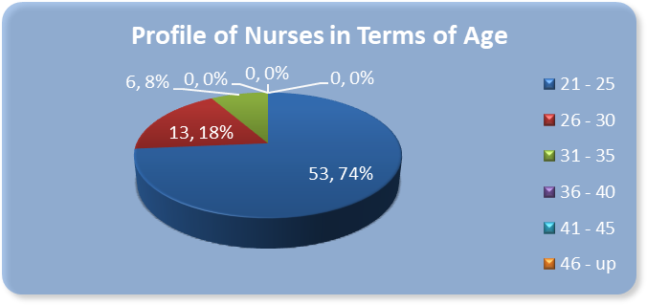

## *Figure 1.1: Frequency and Percentage Distribution on Age of Nurses*

Figure 1.1 shows that 53 or 74% of the respondent nurses are from the age group of 21 - 25 years, the highest of all groups, followed by the age group of 26 - 30 years old with the percentage of 18%, the lowest number of respondents came from the age group of 31 - 35 years of age with the percentage of 8%. The study shows that the majority of nurses employed in the selected tertiary hospital, are new, and young. This means that most of the employed nurses have



just graduated from college. It is also known that institutions recruit nurses who are 21 years to 35 years of age. Another factor is that most senior nurses resign or finish their contracts to work abroad once they have earned their years of experience in the hospital.

# Gender

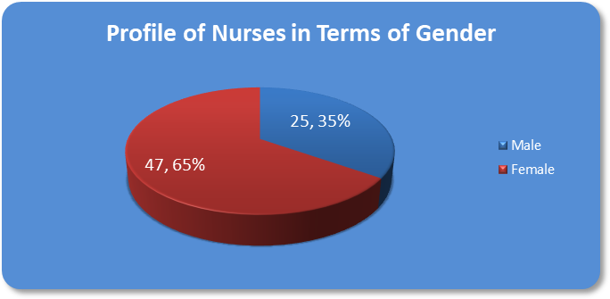

## *Figure 1.2: Frequency and Percentage Distribution on Gender of Nurses*

Figure 1.2 presents the frequency and percentage distribution on the gender of the nurses. Data shows that most of the respondents or 65% are female while only 35% of the respondents are male. This can be interpreted that, nursing is still more of a female dominated career. It can also be said that nursing is more appealing to the girls rather than to the boys who will choose their course in college. This can be attributed to the fact that nursing entails the caring of persons which is similar to motherly care. Females have the common factor of motherly instinct within each of them.



According to Maytum et al in 2004, girls have the playful intention to care for their dolls as do nurses care for their patients. Young girls would imitate and are interested of the role of nurses because they find that nurses are clothed properly, dressed in white and would take care of the sick and wounded.

# Position

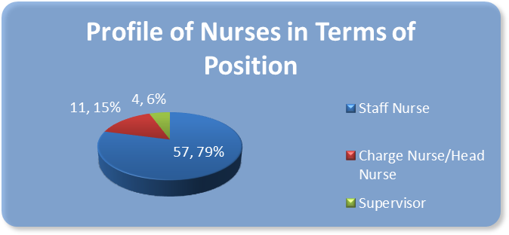

## *Figure 1.3: Frequency and Percentage Distribution on Position of Nurses*

Figure 1.3 presents that most of the respondents or 79% were staff nurses and 15% were charge/head nurses. Only 6% of the respondents who were supervisors. Based on the evident data the staff nurses are the majority in the position held by the respondents. This can be attributed to the fact that the institution has hired newly graduated nurses and must start at the base position as staff nurses. In order to advance their career, masteral units and years of experience are required. Only few nurses rise up as they achieve the proper credentials and the work experience on being promoted to a higher position. According to the American Nurses



Association in 2006, advancement in position entails years of service, expertise and the appropriate degree earned in the post graduate courses. Nurses who want career advancement must attain a Master’s of Science in Nursing. Although it would take a lot of time and effort, the rewards of such endeavor in earning masteral units will be meaningful.

# Highest Educational Attainment

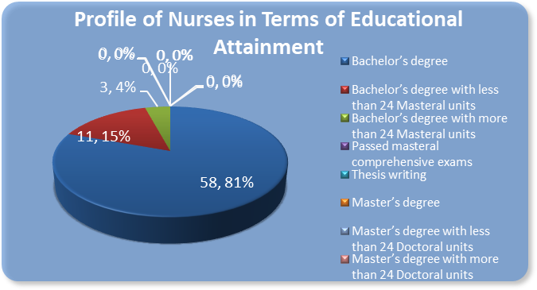

## *Figure 1.4: Frequency and Percentage Distribution on Highest Educational Attainment of* Nurses

Figure 1.4 presents the frequency and percentage distribution on the highest educational attainment of the nurses. Results show that most of the respondents or 58% had only a bachelor’s degree, 15% had BS degree with less than 24 masteral units and only 4% of the respondents had a more than 24 masteral units. This entails that most of the nurses employed are BSN graduates who passed the Nursing Licensure Examination and had not yet enrolled in the masteral course.



It can be pointed out to the fact that due to the work shift and workload of the nurses, they may have little or no time at all in taking up their masters. The job of a nurse is a very tiring occupation which includes bedside care, carrying out of doctors’ orders, medications and other tasks in patient care. According Fairfield in 2007, the importance of career advancement takes a lot of effort and time to be able to rise up the ranks of a certain job.

# Length of Experience

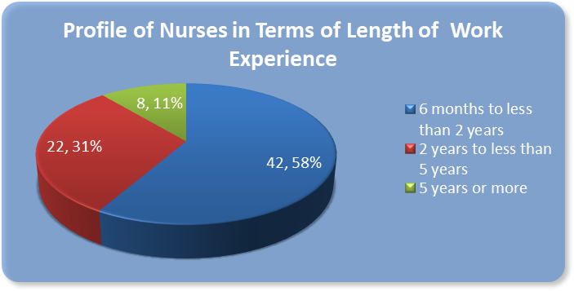

## *Figure 1.5: Frequency and Percentage Distribution on Length of Work Experience of Nurses*

Figure 1.5 shows that 58% or most of the respondents had a work experience of 6 months to less than 2 years. While only 11% of the respondents had 5 years or more of work experience. This can be interpreted that most of the nurses had just graduated and had little experience in the hospital setting. They have a lot to learn regarding patient care, carrying out doctor’s orders, collaboration with other healthcare professionals and other tasks required. It may also be a factor



that in our country, once a nurse has acquired 2 years of experience in the hospital setting they would often seek work as a clinical instructor or go abroad to earn more. According to Anderson in 2006, most institutions have newly hired nurses with less than 2 years of service in the clinical setting. The exodus of nurses to different states and countries is apparent. The common reason is for work benefits and greater salary. The American Nurses Association in 2006 stated that due to the demand of nurses in different states, more and more recruits are coming from different countries to be able to work as a licensed nurse practitioner.

# Career path?



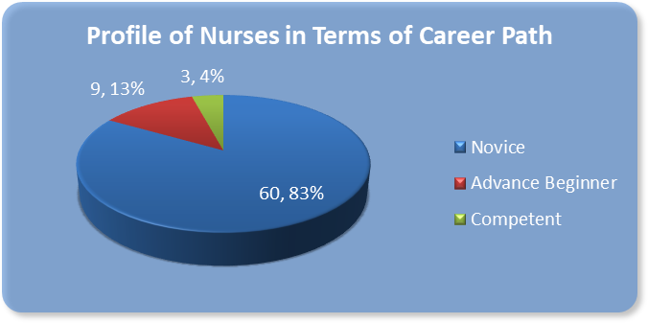

## *Figure 1.6: Frequency and Percentage Distribution on Career Path of Staff Nurses*

Graph above presents the frequency and percentage distribution on the career path of the nurses. This is gathered from the data of tool which determine from the profile of the nurses in relation to their position, the number of masteral units and length of work experience thus categorizing them into the levels of career path which are as follows: the novice, advance beginner and competent nurse. Based from the results, 83% of the respondents fall into the category of a novice nurse; 13% of the respondents belong to the advance beginner while only 4% are categorized as competent nurse. The results show that majority of the nurses employed in the tertiary hospital were novice nurses or inexperienced and have a lot to learn in terms of practice and expertise. According to Jasper in 2005, novice nurses are generally new in the hospital setting. They are expected to gain knowledge, experience and skills throughout their working years. The great number of novice nurses may be due to the fact that there is a great turnover of nurses where the tenured or competent nurses work in other institutions whether



domestic or a foreign . Anderson in 2006 stated that competent nurses with superior experience and education are of greater demand in a globally competitive market.

# Problem Number 2: To what extent do nurses demonstrate their collaborative roles as viewed by physicians and allied health partners along the following aspects:

* 1. **flexibility and interdependence**

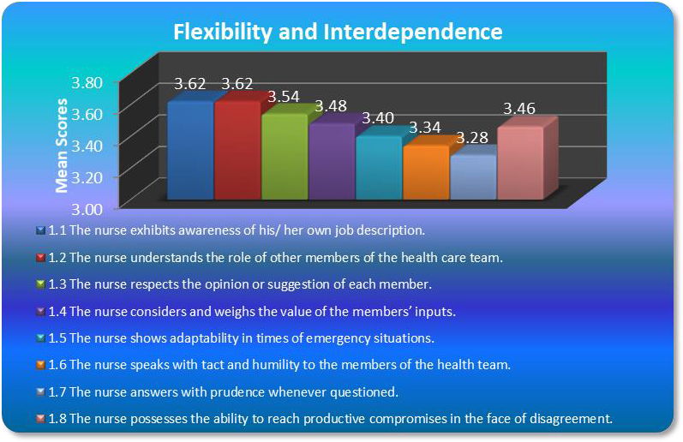

## *Figure 2.1.A. Mean Scores on Specific Items on Flexibility and Interdependence as*

***Evaluated by Physicians***



Figure 2.1.A for flexibility and interdependence as evaluated by the physicians ashows with the following results: the two highest specific tasks which are the nurse exhibits awareness of his / her own job description, and the nurse understands the role of other members of the health care team both received 3.62 as its mean scores. It means that the nurse knows how to function within the health care team. There is no repetition of tasks and so, with that the healthcare team functions with direction or purpose, for the benefit of the clients’ health. The nurse knows her/his duties and does not interfere with the other functions of the team. Furthermore the other high specific task is the nurse understands the role of other members of the healthcare team, the nurse is able to show trust, or confers with the health team the vital details of the patient which may be essential in enhancing the care being rendered to the clients. The nurse knows therefore that she / he is not alone in the implementation of the quality care deemed necessary for the wellbeing of her / his clients. According to Wolfe in 2008, it is critical to have a written job description in place for each unique position. Having a written description accomplishes many important things that protect your institution and your employees. Awareness of good job description serves as a reference guide for determining comparable institutional salaries. Helps maximizes money spent on employee compensation for the position by ensuring experience, and skills needed for the job, are detailed and matched to prospective applicants. It discourages employees from refusing to do something because “it is not my job”, and provides a basis for nurses or employees to review salary increases, setting goals, and growth paths. Awareness of the job description serves as legal documentation that can be useful



in the event that an employee files a termination or discrimination lawsuit against the company. According to Belbin in 2008, he observed that people in teams tend to assume different “team roles”. He defined a “team role” as “a tendency to behave, contribute and interrelate with others in a particular way" and named nine such team roles that underlie team success. Belbin suggests that by understanding team role within a particular team, one can develop strengths and manage weaknesses as a team member, and improve how she/he contributes to the team. Teams can become unbalanced if all team members have similar styles of behavior or team roles. If team members have similar weakness, the team as a whole may tend to have that weakness. If team members have similar team-work strengths, they may tend to compete (rather than co-operate) for the team tasks and responsibilities that best suit their natural styles.

The lowest of which is in the specific task ; the nurse answers with prudence whenever questioned with a mean score of 3.28. When we talk about prudence it is the ability to make intelligent decisions especially in everyday matters (Webster 2008). As shown in the given graph ,the physicians rated the nurses to a moderate extent. The data shows us that the nurses are not able to deliver in an appropriate manner her thoughts, ideas, and opinions to the physicians, thus one can say that the collaboration practice of the nurses in this given area was not that properly done. According to UTC School of Nursing in 2009, nursing care is always tempered by the art and prudence of nursing. Art is the intellectual quality that allows creative investigations, analysis, and synthesis. Prudence is selecting the right reason about things to be



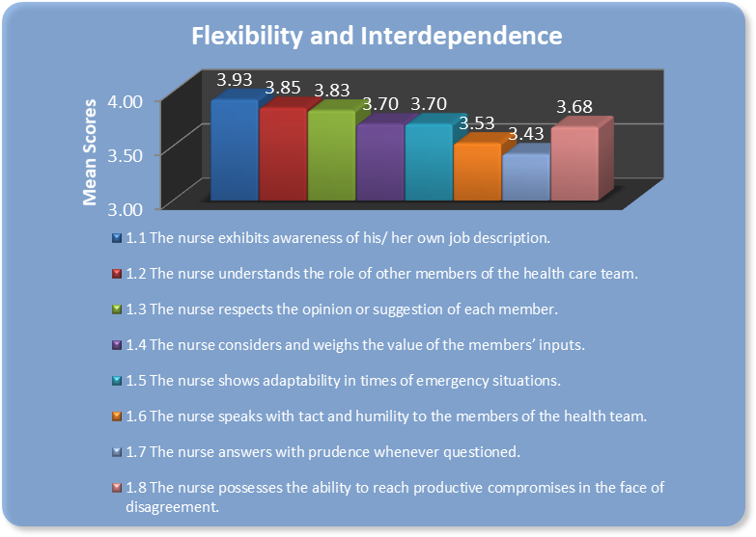done, a virtue of the mind and of the character of individuals. Art and prudence serve nurses in their performance of the interrelated operations of nursing practice.

## *Figure 2.1.B. Mean Scores on Specific Items on Flexibility and Interdependence as*

***Evaluated by Allied Health Partners***

Graph presents the specific items under flexibility and interdependence which obtained highest and lowest ratings from the allied health partners. Results show that allied health partners placed high scores on the item the nurse exhibits awareness of his / her own job description with a mean score of 3.93, The data show that nurses in the selected tertiary hospital were aware of their duties, functions, and relationships with fellow staff nurses and allied health workers. The



85



result is supported by the idea of Borill in 2005 that the nurse is a person who coordinates the work of all the team members and sees that the plan is carried out. For example, the nurse makes sure that the patient's appointments for laboratory investigations are made and kept, sees that treatments are given, and checks to be sure that any needed referrals are made before the patient is discharged. The nurse also plans and supervises the care given by nursing assistants, checks on the work of housekeeping staff assigned to clean the patient's room, and ensures that the patient gets enough healthy food. The family learns how to give basic care from the nurse, who also helps them when necessary. This includes learning how to use traditional ways of healing with modern health care. The nurse supports the family in giving basic care to their sick loved one. It is the nurse who has the final responsibility for the quality of the care the patient receives during the hospital stay. In coordinating the work with others, the nurse always keeps the patient at the centre of concern.

On the other hand, the nurse answers with prudence whenever questioned obtained the least mean score in the category which is 3.43. Nurses may not be able to practice sound judgement in different situations as evaluated by the allied health partners. According to Linton & Lach in 2007, after consideration of the structure, membership, and stage of the health care team, we can proceed to the process of how teams usually conduct their work: through the team meeting. Team meetings can be efficient and effective; however they can also be the source of a great deal of conflict. Everyone in the team needs to agree on the ground rules for team meetings

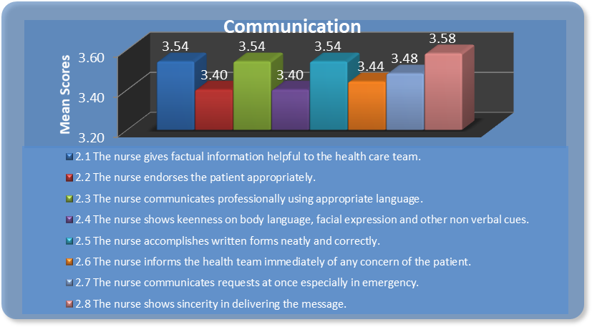

and observe them. The following are points that help create efficient and effective team meetings.

# communication

## *Figure 2.2.A. Mean Scores on Specific Items on Communication as Evaluated by Physicians*

For the graph of communication, the highest specific task is that of the nurse showing sincerity in delivering the message, with mean score of 3.58. Data show that the nurses were able to interpret and tell accurately the current health status of the patient to their physicians. With the accuracy in the reports rendered by the nurses to the doctors the patient is assured of achieving proper and quality healthcare. According to Buchanan & Huczynski in 2004, it is important to recognize that, despite each person’s professional independence, one also relates to



each other as members of the team. This enhances unity, effectiveness and efficiency of the team and meets the individual need for belongingness. Most, though not all, people find this relationship positive. Members of the team relate with each other along a number of dimensions like power, status, liking, communication, roles, and leadership. All dimensions are communicated through non-verbal, verbal, and other communication strategies. Communication with the health care team requires clear management and facilitation on a number of levels, including the following: a. environmental level, b. skills and capabilities level, c. beliefs and values level, d. identity level, e. vision or mission level. Nurses empower the healthcare team by clearly explaining their roles, responsibilities and professional boundaries to facilitate joint working that provides efficient, effective, evidence- based care.

The lowest mean score of 3.40 is that of the two tasks, the nurse endorses the patient appropriately, and the nurse shows keenness on body language, facial expression, and other non verbal cues. Mullen in 2007 also stated that communication is the link that binds a nurse to a patient and a way in which thoughts, needs and feelings are expressed, known and responded to. Since communication does not just concern the verbal but also the non verbal elements we can therefore say that, communication is the articulation of sending a message through different media, what is being transmitted mayb a thought provoking idea, gesture, action, etc. Communication is a learned skill. Based on the data, the item the nurse endorses the patient appropriately performed moderately in the given data. This shows that nurses may not be able to accurately inform the physicians of the changes that are being felt or being seen in the patients.





With this result the physicians will have a more difficult time in accurately making orders for the well being and sake of their patients.

The other specific task that acquire the same moderate mean score of 3.40 is that of the nurse shows keenness on body language, facial expression, and other non verbal ques. Keenness means being intellectually alert or having a characteristic of a quick penetrating mind. Based on the evaluation of the physicians, the nurses were only showing moderate skills in acting to critical or emergency situations. This may mean that during an emergency scenario instead of demonstrating alertness, the nurse may not be able to deliver the necessary nursing care for these crucial events. According to Brooker & Waugh in 2007, gesture is a crucial aspect of non-verbal communication. Some psychologist and linguist suggest that early humans used gesture before the oral or sign language. Gestures can be classified into categories of increasing complexity. Universal gestures that are understood by most people include opening arms and eyes wide to suggest bigness; furrowed brows, pursed lips, drawing body inwards and moving index fingers together would suggest smallness. Subtler gestures include a cupped hand to the mouth to indicate drink, or single upwards gesture of the hand with palm facing upwards suggests that someone standup. Certain gestures are recognized as specific to a language community, such as OK gesture with thumb and index finger touching to make a circle with the other fingers raised. However, it is important to be aware that some gestures that are acceptable in one community are possibly offensive in another.



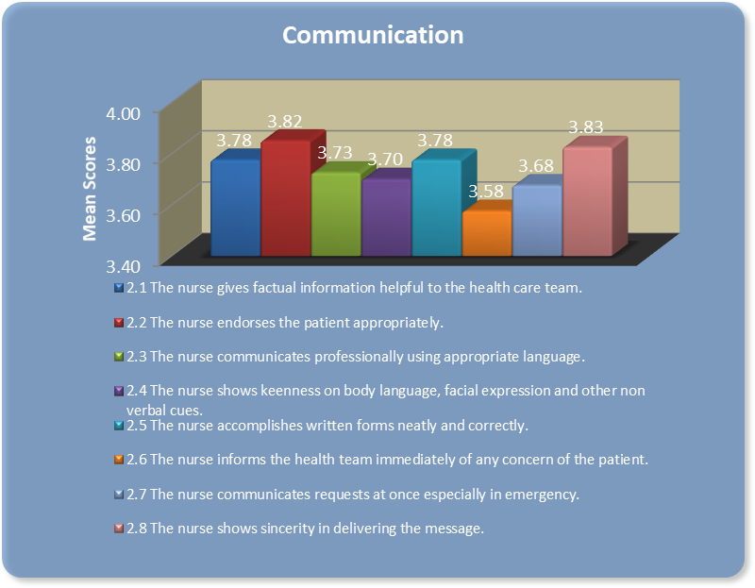

## *Figure 2.2.B. Mean Scores on Specific Items on Communication as Evaluated by Allied* Health Partners

As shown in figure 2.2.B, the highest specific task as rated by the allied health partners is that of the nurse shows sincerity in delivering the message with a mean score of 3.83. Communication is vital to collaboration, as the nurse is perceived to show sincerity in communicating with the allied health partners. It can be said that through such human need, strong bonds of relationship and collaboration may occur. According to Mikanowicz in 2009, communication is a key tool that health care professionals must use to elicit cooperation among



individuals in the delivery of health care services. It is an integral part of socialization and is imperative in establishing relationships. In the medical community, it can be described as a process of sharing information through utilization of a set of common rules. These rules vary with circumstances: for instance, the transfer of information can be interrupted by situational pressure; differences between the professionals' perspectives can interfere with shared meanings; and the rules of the process of communication can be changed with inappropriate responses. Communication among health professionals can increase awareness of a health issue, problem, or solution; affect attitudes to create support for individual or collective action; demonstrate or illustrate skills; increase demand for health services; and inform or reinforce knowledge, attitudes, or behavior. With the disciplines of medicine and nursing working in close proximity, communication is not just practicing together, but individually interacting to achieve a common good: the health and well-being of patients.

On the other hand the specific task the nurse informing the health team immediately of any concern of the patient acquired the least of the mean score which is 3.58. Based on the evaluation of the allied health partners, the nurse in the selected tertiary hospital paid least attention in informing the rest of the healthcare team with any changes that the patient experienced. According to Brooker & Waugh in 2007, the primary purpose of a professional relationship is to work with other professionals in order to fulfill the needs of the core task that is patient / client care. The components of a professional relationship center around the professional skills that participants bring to a relationship so that the core task can be met. Professional



relationships are enhanced through understanding roles and responsibilities, defining boundaries where appropriate, clear communication strategies, openness and honesty, trust, responsibility and accountability.

# collective ownership of goals

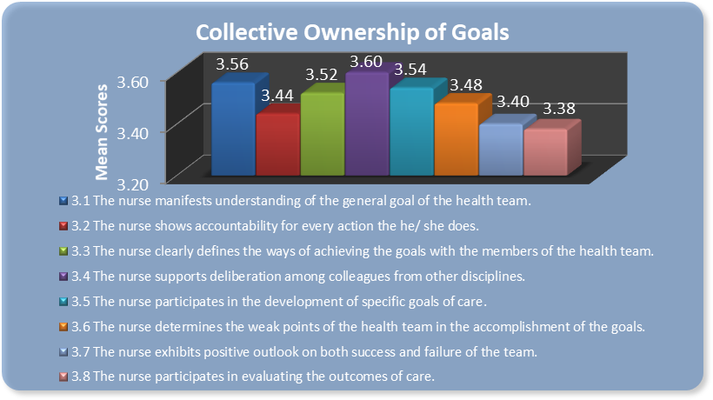

## *Figure 2.3.A. Mean Scores on Specific Items on Collective Ownership of Goals as Evaluated* by Physicians

For the collective ownership of goals the highest specific task that was seen is the nurse supporting deliberation among colleagues from other discipline, with a mean score of 3.60. Based on the graph, the physician evaluated the nurses in this task to a moderate extent.Nurses were seen to be open to comments about their performances, and thus by this they are able to enhance their care towards their patients. Care being rendered means the skills that they practice.



According to Linton & Lach in 2007, at best, conflicts at best, can lead to inefficiencies in team functioning; at worst, they can damage the team’s ability to manage patients. Members may develop low morale and decrease their involvement. However, whenever people are working together to solve problems, there are bound to be disagreements about what to do or how to do it. Conflict helps the team to consider a variety of options. A healthy discussion of differences can help the team solve similar problems more quickly in the future.

The lowest score was that of the specific task of the nurse participating in evaluating the outcomes of care which garnered 3.38 as its mean score. This area performed is rated in a moderate extent as nurses were seen moderately participates in the evaluation of care rendered to the patients. Evaluation is vital, systematic determination of merit, worth, and significance of something or someone using criteria against a set of standards. By evaluation, the health care team would be able to assess fully the outcome of their previous services, and based on the results, improving their future delivery of care. According to Linton & Lach in 2007, given the potential problems in teamwork, it is helpful to think about how a team would appear when functioning effectively.They pointed out the following characteristics of effective teams: purpose, goals, and objectives are known and agreed upon, roles and responsibilities are clear; and communication is open. Disagreement can be expressed without personal attack and team members listen to each other. They are competent, professional, and personally effective, and make appropriate contributions. They cooperate and coordinate activities. When decisions are made, assignments are also, accepted and carried out. There is leadership shifting, depending on



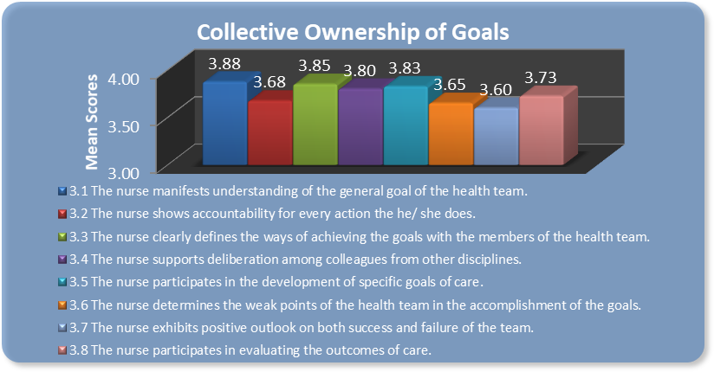the circumstances. Team members support each other and act as different resources for the group.

## *Figure 2.3.B. Mean Scores on Specific Items on Collective Ownership of Goals as Evaluated* by Allied Health Partners

For the graph above, the specific task the nurse manifest understanding of the general goal of the health team acquired the highest mean score of 3.88. The nurses as evaluated by the allied health partners were knowledgeable of the goal of the healthcare team. This means that the nurses, in line with the goals of the allied health partners share adequate understandings on the desired outcomes of care for the patient. According to Borill in 2005, there are many roles of a nurse. The nurse cares for the patient, carries out procedures ordered by the doctor and, in collaboration with the doctor and other team members, assesses the patient and treats his or her



problems. The nurse coordinates with others involved in caring for the patient, including the patient's family, who may have done a lot of the caring for the patient. He/she also protects the patient, works to prevent infection and ensures a safe, healthy environment in the hospital. Finally, the nurse teaches the patient and the family about health-related matters and promotes the patients’ well-being in all situations, speaks for them (advocating), if necessary. The hospital nurse plays many roles on the health care . In taking care of patients, he/she collaborates and works with the other members of the health care team. In many hospitals today the team members together plan for the care of the patient. The nurse is the person who coordinates the work of all the team members and sees that the plan is carried out. For example, he/she makes sure that the patient's appointments for laboratory investigations are made and kept, sees that treatments are given, and checks to be sure that any needed referrals are made before the patient is discharged. The nurse also plans and supervises the care given by nursing assistants, checks on the work of housekeeping staff assigned to clean the patient's room, and ensures that the patient gets enough healthy food. The family learns how to give basic care from the nurse who also helps them whenever necessary. This includes learning how to use traditional ways of healing with modern health care. He/she supports the family in giving basic care to their sick loved one. It is the nurse who has the final responsibility for the quality of the care the patient receives during the hospital stay. In coordinating with other health workers, the nurse always keeps the patient at the centre of concern.



On the other hand, the specific task that obtained the lowest mean score is the nurse exhibiting positive outlook on both success and failure of the team. It obtained the mean score of

3.60. To some allied health partners, some nurses did not show positivism in the care rendered to their patient. According to Guirdham in 2002, positive regard is the ability to hold and convey feelings to other people feelings which are not based on the negative beliefs about the person. Having positive regard to the patients enables the nurse to approach others with positive intentions towards them. Always maintaining positive regard to others can help nurses manage their thoughts, feelings and behaviors even in situations when the others may be behaving inappropriately.



# reflective processes

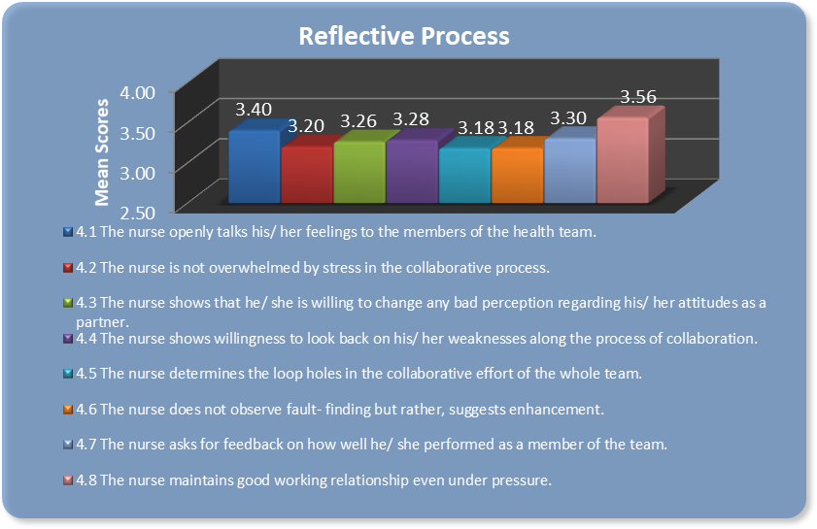

## *Figure 2.4.A. Mean Scores on Specific Items on Reflective Process as Evaluated by Physicians*

For the reflective process, the highest mean score was seen on the specific task of the nurse maintaining good working relationships even under pressure, with a score of 3.56. According to the evaluation of the physicians, the nurses are best at work under pressure, even the relationship being shown by the nurses during crucial moments of the delivery of care are enhanced and they worked efficiently with other healthcare members. According to McCrimmon in 2008, once you set aside family pressures and relaxation, workload pressure is the number one source of stress among employees. Lack of career progress, low pay, conflict with colleagues or poor relationships can also cause a lot of grief, but workload is a big enough topic



on its own. Employees who know how to manage stress focus on factors within their control. People who struggle to cope with pressure blame others or disempower themselves by focusing on the factors that are outside of their control. They say that they have a demanding boss and that is all there is to it. As a result, such employees feel like victims, which only add to their stress. A good general rule, whenever any obstacle or setback arises, is to ask “What can I do?” The key is to focus on the things you can change and not to let yourself be defeated by what is out of your control. One thing people can control is their attitude, which is no easy thing. Nothing or no one does forces you to feel stressed unless you choose it to bother you.

The lowest mean score was seen in the following tasks: the nurse determines the loop holes in the collaborative effort of the whole team, and the nurse does not observe fault-finding but rather, suggests enhancement. Both of these tasks acquired 3.18 as their mean scores. The nurse according to the physicians were unable to see and distinguish the loop holes in the collaborative efforts of the whole health care team. This may mean that the processes that were not useful for the whole team may be redone in the succeeding events of their healthcare. Also, the other specific task the nurse does not observe fault – finding but rather suggest enhancement may mean, that the nurses do not want to hear negative comments of the healthcare team on how they delivered their services, but rather they would like to find ways to improve these services, but without the proper channel of evaluating faults, the process of improvement may not transpire. According to Kurtz et al in 2004, in the therapeutic relationship nurses are trusted to assist change in patients by facilitating the understanding of information. They are also entrusted



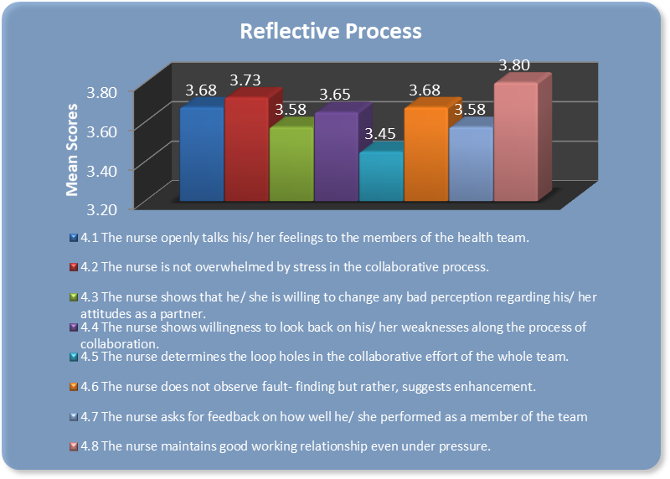with the task of helping a person involved in this health process to move from the current state to a desired state. No one fits all and nurses have to accept that while they continue to value good interpersonal communication skills and strategies. Not all nurse-patient relationships need to be in-depth to be resourceful but it is vital that some are.

## *Figure 2.4.B. Mean Scores on Specific Items on Reflective Process as Evaluated by Allied* Health Partners

For the graph above, the specific task of the nurse maintains good working relationship even under pressure obtained the highest mean score of 3.80. Even under great deal of stress, nurses can work and communicate well with the allied health partners. Stress can play a very



vital role in one’s work performance. According to Matthews in 2006, stress is common to everyone. Human bodies are designed to feel stress and react to it. It keeps us alert and ready to avoid danger. It is not always possible to avoid or change events that may cause stress but an individual can learn to control stress, because stress comes from how the person responds to certain stressful events that occurs in the environment (http://www.deal_with_stress.com/definition_of_stress.html). This stress problem begins in the mind – in our attitude toward life and time and in the things we say to ourselves. It is also very strongly emphasized how important is the way we think in determining our feelings and how we take on life whether with peace and ease or hurriedness and stress. It becomes harmful when stress is continuous, unremitting and not followed by a period of relaxation, rest and recovery. The body is designed for activation and then recovery. One of these stresses is occupational stress. According to Smith and Pergoda in 2005, nurses that are able to cope effectively with stress tend to solve their problems in positive ways. They talk things through calmly until they reach a solution. They respect each healthcare member’s feelings, taking care not to hurt each other and taking time to listen to what each person has to say. They end conflict on a positive note. This style of communication is called affirming communication. It is a vital resource for coping with stress and for maintaining family strengths.

The specific task that obtained the least mean score of 3.45 is the nurse determines loop holes in the collaborative effort of the whole team. The nurses as evaluated by the allied health partners were not investigative enough in determining the weaknesses in the collaborative



process with other members of the health team. According to Watson & Angus in 2002, the need to assess a range of outcomes in nursing care is increasingly important as more patients survive episodes of acute, severe illness. It is vital to discuss the relevance of commonly studied outcomes and the strengths and weaknesses of the techniques used to measure them. Short-term mortality is no longer the only important consideration in the evaluation of a therapy. The assessment of longer-term mortality, morbidity, and patient-centered outcomes is also necessary.

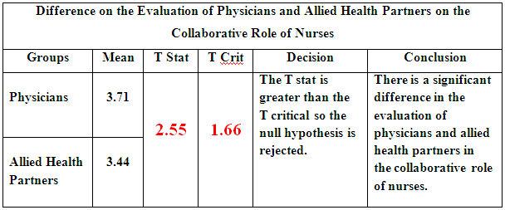

# Problem Number 3: How do physicians and allied health partners differ in their evaluation on the collaborative roles of nurses?

## *Figure 3: Difference on the Evaluation of Physicians and Allied Health Partners on the* Collaborative Role of Nurses

Table above presents the difference on the evaluation of physicians and allied health partners on the collaborative role of nurses. It shows that the nurses obtained a high extent of mean score of 3.71 from the physicians than that of the allied health partners which is 3.44. Data show that nurses have greater collaboration with doctors because nurses have close daily contact of duty with the physicians than those with the allied health partners. Data reveal that the t stat of

2. 55 is greater than the t critical of 1.66. It denotes that there is a significant difference in the evaluation of physicians and allied health partners on the collaborative role of nurses. Data suggest that nurses have a greater collaborative role with the physicians due to the fact that



nurses are duty bound to communicate with them regarding the orders and treatment for the health care of the patients. It is also evident that during rounds the nurse communicates to the physician of the treatment and clarifies orders for the patient’s well being. Unlike for allied health partners, collaboration of the nurses is not that apparent when it comes to patient care Allied health partners collaborate with the nurses when it comes to referrals, gathering of laboratory data and delegation of tasks. According to Kramer and Schmalenberg in 2003, it is stated that collaborative partnerships between the physician and the nurse is of greater worth and effort because it results in better outcomes for patients as well as personal growth for both collaborators.



# Problem Number 4: What scores are obtained by nurses’ own performance on their collaborative roles to the physicians and allied health partners in terms of:

* 1. **flexibility and interdependence**

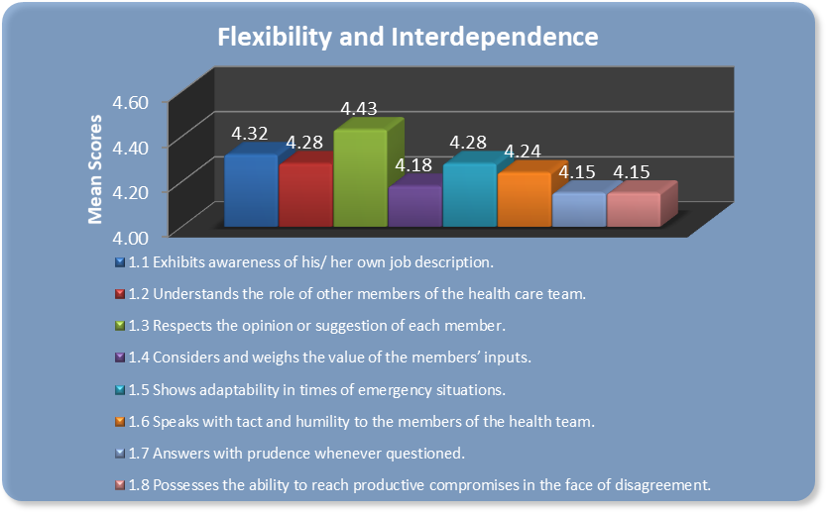

## *Figure 4.1: Mean Scores of Specific Items under Flexibility and Interdependence*

For figure 4.1, the specific task of respects the opinion or suggestion of each other attained the highest mean score of 4.43. Based on the graph, the nurses were able to respect the suggestion of each member of the health team. They were open to new ideas and were in a way supportive to each other . According to Oandasan in 2006, a wide range of collaboration can occur depending on the type of care required. It the concerns of many individuals, families, and communities can be met within the scope of practice of one profession. When healthcare



includes consultation or referral to another professional the practice shifts to interdependent and interprofessional practices. Generally, higher levels of collaboration are needed when health needs are complex and individuals receiving care require the skills of several health professionals. Collaboration among health professionals is dynamic and occurs within a spectrum from independent parallel practice with autonomous health professionals working side by side; to consultation and referral where health professionals exchange information; to interdependent co-provision of care with interdependent decision-making.

The specific task that garnered the lowest mean score of 4.15 are the specific tasks answers with prudence whenever questioned, and possesses the ability to reach productive compromises in the face of disagreement. According to Holmes in 2001, spoken words are arbitrary representations of ideas that have been agreed by people who use a language. In other words, they are an agreed sound or group of sounds that we know, represents a thing or an action. Without such agreement on the meaning, the words would be non- sensical or idiosyncratic, understood only by the person who produced them. As such they would not be useful to others though they may hold a great deal of significance for the person who created the sound. Verbal communication usually has written equivalents, although some languages do not. Nurses employ various verbal communication strategies to develop relationships, seek and understand information, provide feedback to others and to demonstrate professional compassion and self awareness.



# communication

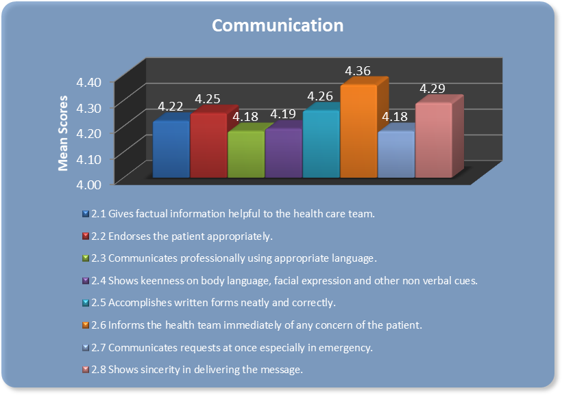

## *Figure 4.2: Mean Scores of Specific Items Under Communication*

Figure 4.2 presents the mean scores of specific items under communication, the specific task of informs the health team immediately of any concern of the patient attained the highest mean score of 4.36. The nurses understood the importance of informing the healthcare team of any changes in the health status of the patient. According to Dayapera in 2008 communication is the method or a process by which people share their ideas, information, opinions and feelings. Kozier in 2004 defined communication as a mode of promoting understanding and establishing a constructive relationship between the nurse and patients or the nurse and the health care team.



Good nurse-patient interaction starts with good communication. Mullen in 2007 also stated that communication is the link that binds a nurse to a patient and a way in which, thoughts, needs and feelings are expressed, known and responded.

The specific task communicate professionally using appropriate language and communicates request at once especially in emergency both obtained the mean score of 4.18. Although the specific tasks obtained the lowest of all the mean scores, it still obtained a high extent. According to Henry in 2005, collaborative interactions are most effective and rewarding when they are efficient. When information is exchanged in emergency situations, for instance, it is critical to prioritize, to leave out peripheral data, and to provide current information. Henry offers tips for communicating in emergencies. These tips include: getting the facts from informed sources, not blowing issues out of proportion, responding promptly and calmly, and divulging only what others need to know and ethically ought to know. Following up on issues later and debriefing about processes and outcomes will also enhance collaborative efforts and relationships that deal with emergencies and crises.



# collective ownership of goals

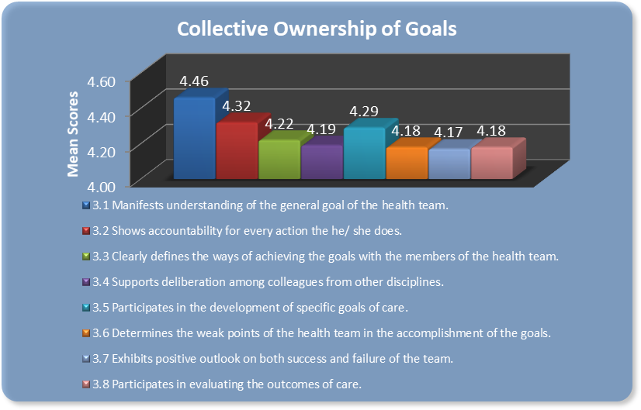

## *Figure 4.3: Mean Scores of Specific Items under Collective Ownership of Goals*

Figure 4.3 shows the mean scores of specific items under collective ownership of goals. The specific task manifests understanding of the general goal of the health team attained the highest mean score of 4.46. The nurses in the selected tertiary hospital understood the goal of the entire health team, their aim is to give all out quality nursing care for their patients. According to Hackman in 2005, developing a healthcare system that values teamwork and supports patient-centered care requires a clear understanding of the complex nature of teamwork; the effect of different organizational contexts; and the impact of different policies, legislation, and regulations. For effective teamwork to take place, a co-ordinated effort among key



stakeholders across the healthcare system (such as healthcare providers, organizational leaders, decision makers) is required to integrate the components that need to occur at all levels of the healthcare system.

The specific task that obtained the lowest mean score is the nurse exhibits positive outlook on both success and failure of the team. It garnered 4.17 as its mean score. According to Brooker and Waugh in 2007, being concerned enhances the nurse-patient relationship. Nurses develop a protective feeling towards the people they work with while at the same time recognizing the need for the patient to make their own decisions about their lives and their health. Nurses were clear that their role was to offer choice and alternatives to facilitate the patient in problem solving.



# 2.4 reflective process

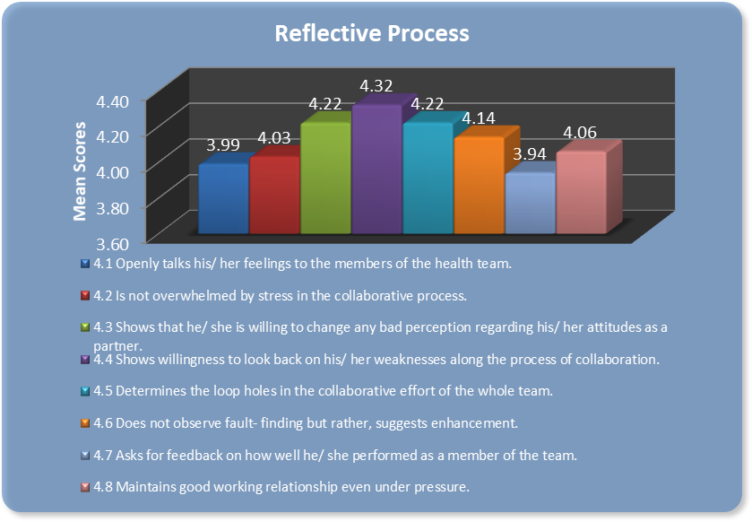

## *Figure 2.4: Mean Scores of Specific Items Under Reflective Process*

The graph above shows the mean scores of specific items under reflective process. The specific task of showing willingness to look back on his / her weaknesses along the process of collaboration attained the highest mean score of 4.32. The nurses employed in the selected tertiary hospital was able to view past experiences and are able to enhance their care practice by examining the weaknesses during the collaborating process with other members of the health team. According to Kramer in 2003, the key to the establishment of interdisciplinary teams is a needs assessment to determine the health needs of the community and practice population. For



example, the hospital may have a large number of disenfranchised mothers or elderly patients requiring diabetic foot care, all of whom could benefit from the establishment of a team of providers with skills unique to their professions. Population and patient needs assessments should be key determinants in deciding what kinds of teams are required and how to define interdisciplinary collaboration. Needs assessments will also define the funding required to support resources required in the establishment of patient care teams. It is recommended that primary care groups be created and configured to meet the healthcare needs of the patient population, as defined by patient demographics and other data analyses related to the health of the population being served.

On the other hand ,the lowest mean score was from the specific task the nurse asking for feedback on how well he / she performed as a member of the team, garnering 3.94, although attaining the lowest mean score it is still to a moderate extent. According to Lomas in 2005, Nurses care for the sick and injured in hospitals where they work to restore health and alleviate suffering. Many people are sent home from the hospital when they still need nursing care, so nurses often provide care in the home that is very similar to the care they give to patients in the hospital. In clinics and health centers in communities where in there are few doctors, nurses diagnose and treat common illnesses, prescribe and dispense medications and even perform minor surgery. Nurses are also increasingly working to promote people’s health and to prevent illness in all communities.



# Problem Number 5: How do nurses differ in the performance of their collaborative roles when grouped according to their career pathway?

## *Figure 5.1: Mean Scores of Collaboration of Nurses According to Career Pathway*

Graph above shows the mean scores on the collaboration of nurses when grouped according to career pathway. The result presents that among the 3 levels of career pathway, competent nurses have the highest mean in terms of collaboration with an accumulated score of

4.69. The result is based on the fact that these nurses are tenured, have a greater work experience and have higher position than the others. According to Jasper in 2005, the competent nurse is one who has mastered sufficient technical skills and is aware of patterns of responses consults with other members of the healthcare team and work efficiently with them. It is evident that competent nurses have a wealth of experience within the clinical environment and consider themselves in collaborative care though the years. Novice nurses have the least mean score of

4.18. It is evident that novice nurses are generally new in the hospital setting. They are expected



to gain knowledge, experience and skills throughout their working years. These nurses need to be safe in what they are doing and therefore require supervision and cooperation with other healthcare members such as the physicians and senior co-workers (Jasper, 2005).

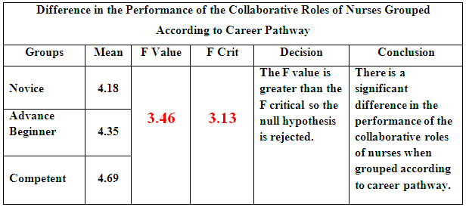

## *Figure 5.2: Difference in the Performance of the Collaborative Roles of Nurses Grouped* According to Career Pathway

Table above shows the difference in the performance of the collaborative roles of the nurses when grouped according to career pathway. Data tested at 0.05 level of significance presents that the F value of 3.46 is greater than the F critical of 3.13. It reveals that there is a significant difference in the performance of the collaborative roles of nurses when grouped according to career pathway.



# Problem Number 6: What role enhancement program can be suggested to enhance the collaboration of the staff nurses to the physicians and allied health partners?

The Role Enhancement Program or REP is based on improving the collaborative efforts of the nurses and contains activities and pointers on how to collaborate effectively with the physicians and allied health partners. The researcher devised and made this program for the use of institutions to aid in the enhancing the collaboration of the healthcare team. Please refer to the appendices for the REP.



# Chapter V

# SUMMARY, FINDINGS, CONCLUSIONS AND RECOMMENDATIONS

This chapter presents the summary of the study, the significant findings, the conclusions and recommendations..

# Summary

This study aimed to determine the effectiveness of nurses as collaborators as evaluated by the physicians, and other allied health partners.

Specifically, It sought to answer the following questions:

1. What is the profile of nurses in terms of:
   1. age;
   2. gender;
   3. position;
   4. highest educational attainment;
   5. length of experience; and
   6. Career path?
2. To what extent do the physicians and allied health partners evaluated the collaborative roles of nurses along the following aspects:
   1. flexibility and interdependence;
   2. communication;
   3. collective ownership of goals; and



* 1. reflective process?

1. How do the evaluation of the physicians and allied health partners differ on the collaborative roles of nurses?
2. What are the scores obtained by the nurses’ own rating on their collaborative roles to the physicians and allied health partners in terms of:
   1. flexibility and interdependence;
   2. communication;
   3. collective ownership of goals; and

4.5 reflective process?

1. How do nurses differ in the performance of their collaborative roles when grouped according to their career pathway?
   1. novice;
   2. advance beginner; and
   3. competent?
2. What role enhancement program can be suggested to enhance the collaboration of the staff nurses to the physicians and allied health partners?

There are 2 hypotheses that the researcher came up with. These are:

There is no significant difference in evaluation of physicians and allied health partners on the collaborative role of nurses.



There is no significant difference in the performance of the collaborative role of nurses when grouped according to novice, advance beginner, and competent nurses.

This study on the “Collaborative Roles of Nurses as Evaluated by Physicians, and Allied Health Partners: Input to the Formulation of a Role Enhancement Program” utilized a descriptive- comparative design to measure the significant variables in this research. As a comparative study, this research established the comparison between the evaluation of the physicians’ and allied health partners’ on the collaborative role of nurses.

This research study utilized a purposive sampling technique. The following criteria were used for this research study:

* 1. Nurses working on a permanent basis in the selected tertiary hospital, namely, The Philippine Heart Center. Nurses who met the criteria of a novice, advance beginner and competent were included in the study:
  2. Novice **–** entry level staff nurses with at least 6 months to less than 2 years of tenure in the hospital.
  3. Advance beginner – charge nurses and head nurses with at least nine units in MA in Nursing and working experience of 2 years clinical nursing.
  4. Competent - head nurses and nurse supervisors with at least thirty units in MA in nursing and working experience of 5 years clinical nursing.



* 1. Resident physicians working on a permanent basis in the above mentioned tertiary hospitals.
  2. Allied health partners including the medical technologists, pharmacists and therapists working on a permanent basis in the above mentioned tertiary hospital.

This research included all the nurses, physicians, and allied health partners who entered the criteria to ensure accuracy, depth and comprehensiveness of the study.

Seventy- two nurses served as the main respondents working on a regular basis in the standard area with at least 6 months of experience. Fifty(50) respondents out of 90 resident physicians were respondents. Meanwhile, the researcher was able to gather 40 allied health partners ranging from medical technologists, pharmacists and physical therapists working on a permanent basis in the above mentioned tertiary hospital.

For the research instrumentation, the first questionnaire is tagged as the “Collaboration Efficacy Index”. This tool is composed of two parts. Part I focused on determining the selected profile variates like educational attainment and years of experience in order to classify the nurses as novice, advance beginner and competent. Part II contains the factors and specific items which focused on evaluating the collaborative role of nurses. This questionnaire was based from the theory and concept of Bronstein (2003). The elements involved in this tool include interdependence and flexibility, communication, collective ownership of goals and reflective



process. Under each element, 8 sub-items were formulated and consequently, 32 questions were developed. A five point scale was employed for this tool:

5- Very high extent 4- High extent

3- Moderate extent

2- Low extent 1- Not at all

The content validity of this research instrument was checked by an expert and the reliability was also checked through a pre testing. It was carried out at San Juan De Dios Hospital, where 10 staff nurses who qualified in the actual criteria were chosen, including 10 physicians, and 10 allied health partners. Pearson r was employed to check the tool’s reliability. The score was 0.9799 which indicates that the questionnaire is highly reliable.

After the collection of sufficient data, the data was encoded in a data matrix and statistical treatment followed. The data that were gathered from the evaluative questionnaire underwent statistical treatment using Microsoft excel.

The data gathered from the research instruments underwent statistical treatment through statistical tools, in lieu of the analysis of data. The tools that were used in this study were: a) weighted mean, b) percentage distribution c) t test and d) analysis of variance.



To determine the extent to which the respondents evaluate the collaborative role of nurses along the following aspects of flexibility and interdependence, communication, collective ownership of goals and reflective process, weighted mean was employed.

To determine the evaluation of the respondents on the collaborative role of nurses differ when grouped according to physicians, and allied health partners, t test assuming unequal variances was donee.

To determine the scores obtained by the nurses’ own rating on their collaborative roles to the physicians and allied health partners in terms of flexibility and interdependence, communication, collective ownership of goals and reflective process, weighted mean was employed.

To determine the difference in the nurses’ performance of collaborative role when grouped according to novice, advance beginner and competent, analysis of variance was used. A One-Way Analysis of Variance is a way to test the equality of three or more means at one time by using variances.

Microsoft Excel was the most appropriate program utilized by the researcher to treat and process the data obtained from the study with full accuracy.



# Findings

Based on the data gathered in this study, the following are the salient findings:

# What is the profile of nurses in terms of:

* 1. **age;**

Graph shows that 53 or 74% of the respondent nurses are from the age group of 21 -25 years, the highest of all groups, followed by the age group of 26 - 30 years old with the percentage of 18%, the lowest number of respondents came from the age group of 31 - 35 years of age which is 8%.

# gender;

Data shows that most of the respondents or 65% are female while only 35% of the respondents are male. This can be interpreted that although we live in the modern time nursing is still more of a female dominated career.

# position;

Graph presents that most of respondents or 79% were staff nurses and 15% were charge/head nurses. Only 6% of the respondents were supervisors. Based on the evident data the staff nurses are the majority in the position held by the respondents.



# highest educational attainment;

Results show that most of the respondents or 58% have only a bachelor’s degree, 15% have bachelor’s degree with less than 24 masteral units and only 4% of the respondents have a bachelor’s degree with more than 24 masteral units.

# length of experience; and

Graph above shows that 58% or most of the respondents have a work experience of 6 months to less than 2 years. While only 11% of the respondents have 5 years or more of work experience.

# career path?

Based from the results, 83% of the respondents fall into the category of a novice nurse; 13% of the respondents belong to the advance beginner while only 4% are categorized as competent nurse. The results show that majority of the nurses employed in the tertiary hospital are novice nurses who are inexperienced and have a lot to learn in terms of practice and expertise.



# To what extent do the physicians and allied health partners evaluated the collaborative role of nurses along the following aspects:

* 1. **flexibility and interdependence; As Evaluated by Physicians:**

Graph for interdependence and flexibility as evaluated by the physicians aspired with the following results: the two highest specific tasks where the nurse exhibits awareness of his / her own job description, and the nurse understands the role of other members of the health care team, both received 3.62 as its mean scores. The lowest of which is in the specific task of; the nurse answers with prudence whenever questioned, with the mean score of 3.28.

# As Evaluated by Allied Health Partners:

Results show that allied health partners placed high scores on the item of the nurse exhibits awareness of his / her own job description with the mean score of 3.93. On the other hand, the nurse answers with prudence whenever questioned obtained the least mean score in the following category with 3.43.

# communication;

**As Evaluated by Physicians:**

For the graph of communication, the highest specific task was that of the nurse shows sincerity in delivering the message, with the mean score of 3.58. The lowest mean score of



3.40 was acquired by two tasks, the nurse endorses the patient appropriately, and the nurse shows keenness on body language, facial expression, and other non verbal cues.

# As Evaluated by Allied Health Partners:

As stated in the graph above, the highest specific tasked rated by the allied health partners is the nurse shows sincerity in delivering the message with a mean score of 3.83. On the other hand the specific task the nurse informs the health team immediately of any concern of the patient acquired the least of the mean score with 3.58.

# collective ownership of goals; and As Evaluated by Physicians:

For the collective ownership of goals the highest specific task that was seen on the nurse supports deliberation among colleagues from other discipline, with the mean score of 3.60. The lowest score was attained from the specific task of the nurse participates in evaluating the outcomes of care; it garnered 3.38 as its mean score.

# As Evaluated by Allied Health Partners:

The specific task the nurse manifest understanding of the general goal of the health team acquired the highest mean score with 3.88. On the other hand the specific tasked that obtained the lowest mean score is the nurse exhibits positive outlook on both success and failure of the team. It obtained the mean score of 3.60.



# reflective process?

**As Evaluated by Physicians:**

For the reflective process, the highest mean score was seen on the specific task of the nurse maintains good working relationships even under pressure, with the mean score of

3.56. The lowest mean score was seen in both tasks: the nurse determines the loop holes in the collaborative effort of the whole team, and the nurse does not observe fault-finding but rather, suggests enhancement. Both these tasks acquired 3.18 as there mean scores.

# As Evaluated by Allied Health Partners:

The specific task of the nurse maintains good working relationship even under pressure obtained the highest mean score of 3.80. The specific task that obtained the least mean score of 3.45 is the nurse determines loop holes in the collaborative effort of the whole team.

# How do the evaluation of the physicians and allied health partners differ on the collaborative role of nurses?

Data reveals that the t stat of 2. 55 is greater than the t critical of 1.66. It denotes that there is a significant difference in the evaluation of physicians and allied health partners on the collaborative role of nurses.



# What are the scores obtained by the nurses’ own rating on their collaborative roles to the physicians and allied health partners in terms of:

* 1. **flexibility and interdependence;**

The specific task of respects the opinion or suggestion of each other attained the highest mean score of 4.43. The specific task that garnered the lowest mean score 4.15 are the specific tasks answers with prudence whenever questioned, and possesses the ability to reach productive compromises in the face of disagreement.

# communication;

Graph presents the mean scores of specific items under communication, the specific task of informs the health team immediately of any concern of the patient attained the highest mean score with 4.36. The specific tasks communicate professionally using appropriate language and communicates request at once especially in emergency both tasks obtained the mean score or 4.18.

# collective ownership of goals; and

The graph shows the mean scores of specific items under collective ownership of goals. The specific task manifests understanding of the general goal of the health team attained the highest mean score of 4.46. The specific task that obtained the lowest mean score is the nurse exhibits positive outlook on both success and failure of the team; it garnered 4.17 as its mean score.



# 4.5 reflective process?

The specific task of shows willingness to look back on his / her weaknesses along the process of collaboration attained the highest mean score of 4.32. On the other hand the lowest mean score was from the specific task the nurse asks for feedback on how well he / she performed as a member of the team, garnering 3.94, although attaining the lowest mean score it is still of a moderate extent.

# How do nurses differ in the performance of their collaborative roles when grouped according to their career pathway: novice, advance beginner, and competent?

The result presents that amongst the 3 levels of career pathway, competent nurses have the highest mean in terms of collaboration with an accumulated score of 4.69. Novice nurses have the least mean score of 4.18. Data tested at 0.05 level of significance presents that the F value of 3.46 is greater than the F critical of 3.13. It reveals that there is a significant difference in the performance of the collaborative roles of nurses when grouped according to career pathway.

# What role enhancement program can be suggested to improve the collaboration of the staff nurses to the physicians and allied health partners?

The Role Enhancement Program or REP is based on improving the collaborative efforts of the nurses and contains activities and pointers on how to collaborate effectively with the physicians and allied health partners. Please refer to the appendices for the REP.



# Conclusions

Based on the findings of the researchers, the following conclusions were drawn:

There is a significant difference in the evaluation of physicians and allied health partners on the collaborative role of nurses.

There is a significant difference in the performance of the collaborative roles of nurses when grouped according to career pathway.

# Recommendations

On the basis of the findings and conclusions, the following recommendations are given:

1. The selected tertiary hospital should have a regular evaluation on the collaborative performance of their staff nurses and present strategies that would help improve the collaborative efforts of nurses to the physicians and allied health partners.
   1. The nursing service and hospital administration should conduct seminars and workshop on collaboration to enhance the nurses’ collaborative performance especially to novice nurses. This is to improve the patient care and workflow within the clinical setting.
   2. The nursing service shoud have trainings for the nurses regarding prudence in answering questions from the healthcare team. Seminars on effective communication techniques could also be implemented for the nurses to develop their way of communicating to the patients as well as other healthcare workers.



* 1. The researcher suggests that nurses should participate with other healthcare members in evaluating the outcomes in patient care. This is based from the low score on collaboration of nurses in participating in evaluating outcomes of patient care.

1. The nurse supervisors, charge nurse and other tenured nurses should encourage and properly supervise the the staff nurses especially the novice nurses in exhibiting a positive outlook for every decisions made by the healthcare team.
   1. The nurse manager should regularly check the nurse on appropriateness on the endorsement of their patient to the physicians and other allied health partners.
   2. The nurse manager should remind the nurses that they should notify immediately to the healthcare team or their supervisors on concerns regarding their patients.
   3. The researcher recommends that the nurse managers should encourage the staff nurses in determining the gaps in the collaborative effort of the team and suggest ways of overcoming them.
2. The resercher recommends that the deans and the colleges of nursing may enhance their related learning experince specifically the collaborative roles of nurses with the other members of the helath care team.
3. The researcher recommends that future research must be made on determining the collaborative performance of the physicians and allied health partners as evaluated by the nurses. This is to provide a definite view on how well the physicians and the allied health partners collaborate and work with the nurses.



1. The proposed collaboration enhancement program be implemented and asssessed in terms of effectiveness.



# Bibliography

**Books**

Anderson, C. (2006). The Nurse: A Vital Profession in a Globally Competitive Market.

Thomson-Peterson's Inc.

Belbin, M. (2008). How Understanding Team Notes Can Improve Team Performance. [Henley](http://en.wikipedia.org/wiki/Henley_Management_College) [Inc.](http://en.wikipedia.org/wiki/Henley_Management_College)

Brooker, C. & Waugh, A. (2007). Foundations of Nursing Practice Fundamentals of Holistic Care. Mosby Inc.

Buchanan & Huczynski A (2004). Organisational Behaviour: An Introductory Text.

Prentice Hall, London.

Fairfield, A. (2007). Career Planning: A Guide for Nurses. Harlow, Thomson-Peterson's Inc.

Guirdham, M. (2002). Interactive Behaviour at Work. 3rd Ed. Financial times Prentice Hall, London

Henry, R. (2005). You’d Better Have a Hose if You Want to Put Out the Fire. Windsor CA: Gollywobbler Inc.

Holmes, J. (2001). Introduction to Sociolinguistics. Longman London Inc.

Kozier, B. (2004). Fundamentals of Nursing: Concepts, Process and Practice. Seventh Ed. New Jersey: Pearson Education Inc.

Kramer, M., & Schmalenberg, C. (2003). Nursing Management.

Securing "Good" Nurse Physician Relationship. Thousand Oaks CA Inc.

Kurtz, et al. (2004). Teaching and Learning Communication Skills in Medicine. 2nd ed.

Radcliffe Publishing, Oxford



Lach, H. & Linton, A. (2007). Gerontological Nursing Concepts and Practice. 3rd Ed.

Saunders, Inc.

Jasper, M. (2005). Nursing Professional Development, Reflection and Decision-Making.

Blackwell Publishing

Mikanowicz, C. (2009). Strategies for Developing Communication Between Nurses and Physicians. National Center of Continuing Education, Inc.

Mullen, M. (2007). Domains Challenging the Nursing Profession. McGraw-Hill Inc.

Potter P and Perry A. (2005). Fundamentals of Nursing. New Jersey: Pearson Education Inc. Venzon, L. (2004). Introduction to Nursing Research. Philippines: C and E Publishing Inc.

Watson, P. (2002). Ideas: A History of Thought and Invention from Fire to Freud. Harper Collins Inc.

# Journals

American Nurses Association. (2006) "Nursing Facts: Today's Registered Nurse - Numbers and Demographics" **Journal of American Nurses Association** 27; 25-31

Black, L. (2002). A Dynamic Theory of Collaboration: A Structural Approach to Facilitating Intergovernmental Use of Information Technology. ***Computer Socieyt,*** 1:1-13

Borrill, C. (2005). Team working and effectiveness in health care. ***British Journal of Health Care,*** 6: 364-371.

Brandi C. (2000) Relationships between nurse executives and physicians: the gender paradox in healthcare. ***Journal of Nursing Administration***, 30: 373-378

Cook, N. and Brown, J. (2000) Bridging Epistemologies: The Generative Dance Between Organizational Knowledge and Organizational. ***Organization Science****,* 10: 381-400.

Disch J, Bellman G, Ingbar D. (2001). Medical directors as partners in creating healthy work environments. ***AACN Clinical Issues***, 3: 366-377.



Foley B, Kee C, Minick P, Harvey S. (2002). Characteristics of nurses and hospital work environments that foster collaboration, satisfaction and clinical expertise. ***Journal of Nursing Administration,*** 5: 273-282.

Garcia, A. (2004) Attitudes Toward Physician-Nurse Collaboration: A Cross-Cultural Study of Male and Female Physicians and Nurses in the United States and Mexico. ***Journal of Professional Nursing***, 20: 310-322

Griswold, A. (2006). Enhancing Teamwork and Collaboration in Your Unit. ***Innovation Insights***, 2: 2-4

Hackman, C. (2005). Collaboration Between Nurses and Physicians: No Longer a Choice.

***Academic Medicine****, 67*(5), 295-303.

Iacono M. (2003). Conflict, communication, and collaboration: improving interactions between nurses and physicians. ***Journal of Perianesthesia Nursing,***18: 42-46.

Kramer M. (2003). Securing a "good" nurse/physician relationships. ***Nursing Management***, 3: 34-38.

Lockhart K. (2006). Collaboration between nurses and doctors in clinical practice. ***British Journal of Nursing***. 5: 276-280.

Lomas, J. (2005). Conceptualizing and combing evidence for health system guidance: ***Final report.*** Ottawa, ON: Canadian Health Services Research Foundation

Lyles, E. and Oliver, D. (2007). The Power of Collaboration in Hospice Setting. ***University of Leeds***, 15: 1-12

Oandasan, I. (2006). Interprofessionality as the field of interprofessional practice and interprofessional education: An emerging concept. ***Journal of Interprofessional Care***, 19: 8-20

Matthews, D. (2006). The Ups and Downs of Stress. **Christian Lifestyle Magazine**, Vol. 6, No.

4, p. 15

Maytum, J., Heiman, M., & Garwick, A. (2004). Compassion in Nurses Who Work With Children and Their Families. ***Journal of Pediatric Health Care*** 18, 171-179.



Nelson, B. and Fewster, L. (2008). Interdisciplinary Collaboration for Health Care Professionals.

***Nursing Adnistartion Quarterly***, 32: 40-48

Simpson E. and Weiner S. (2006). Graphic Design: Collaborative Processes: understanding Self and Others. ***Article 325: Collaborative Processes***, 3: 25-27

Smith, M., & Pergoda, S. (2005). Working Together But Apart: Barriers and Routes to Nurse- Physician Collaboration. ***The Joint Commission****, 28*(5)*,* 242-247.

Stein L. (2007). The doctor-nurse game. ***Arch Gen Psychiatry*,** 16: 699-703

Sterchi, S. (2007). Perceptions that Affect Physician-Nurse Collaboration in Perioperative Setting. ***AORN Journal,*** 1: 18

Thomas, S. (2005). Teamwork and Collaboration. Journal of Issues in Nursing, 10: 1-10 Vera, J. (2007). Creative Collaboration. ***AACN Clinical Issues***, 30:41-42

Wagner, C. (2005). [Globalization in the network of science: Diffusion of international](http://users.fmg.uva.nl/lleydesdorff/cswagner07/index.htm) [collaboration and the formation of a core group](http://users.fmg.uva.nl/lleydesdorff/cswagner07/index.htm). ***Science Journal***, 2: 2-3

Watson, R. & Angus, D. (2002). Assessing Outcomes in Critical Care. ***Journal of Intensive Care Medicine*,** Vol. 17, No. 3, 103-111

Weinstein S. (2003). Enhancing nurse-physician collaboration: a staffing innovation. ***Journal of Nursing Administration***, 4: 193-195.

Yeager, S. (2005). Interdisciplinary Collaboration: The Heart and Soul of Health Care. ***Critical Care Nursing.*** 17: 143-148

Zander, U., & Kogut, B. (2005). Knowledge and Speed of the Transfer and Imitation of Organizational Capabilities: An Empirical Test. ***Organization Science****, 6*: 76-92.

Zwarenstein, M. (2000). What’s So Great about Collaboration. ***BM Journal***, 320: 1022-2023



# Unpublished Thesis

Dayapera, M. (2008). Stress and Performance Efficiency of Staff Nurses in Selected Private Hospital. Concordia College

Jardio, S. (2008). Nurses’ Workload and Clinical Performance of Staff Nurses in Different Shifts. Concordia College

# Online Resources

McCrimmon, M. (2008). Burn! 7 Leadership Myths in Ashes. <http://businessmanagement.suite101.com/article.cfm/coping_with_pressure_at_work>

UTC School of Nursing, (2009) <http://www.utc.edu/Academic/Nursing/philosophy.php> Webster’s Online Dictionary (2008) Available online [www.google.com](http://www.google.com/)

Wolfe, L. (2008). Human Resources: Managing Employees and Protecting Your Business <http://womeninbusiness.about.com/od/managingemployees/>

(http://www.deal_with_stress.com/definition_of_stress.html)